The exam contained two sections

The first section had two business use cases wih 4 and 5 questions each

Date formatting with M query and Dates in INTEGER format

The second section had 48 question

Share Point Online List with multiple document librarries and one was a library with Excel Marketing sheets

GOOGLE:

Site:app.powerbi.com

### Connect to a Power BI service dataset using a live connection

Anna creates a report and creates the dataset it's based upon. Anna then publishes it to the Power BI service. The report shows up in the team's workspace in the Power BI service. If Anna saves it to a new experience workspace. Anna can set Build permission to make it available to everyone in and out of their workspace to see and use.

Other members in and out of Anna's workspace can now establish a live connection to Anna's shared data model using the Power BI service live connection feature. They can create their own unique reports, from their original dataset, in their own new experience workspaces.

Now that your report with its dataset is in the Power BI service, you can also promote it. Promotion means that you attest to its quality and reliability. You can even request that it be certified by a central authority in your Power BI tenant. With either of these endorsements, your dataset always appears at the top of the list when people are looking for datasets. For more information, see [Promote your dataset](https://docs.microsoft.com/en-us/power-bi/connect-data/service-datasets-promote).

The last step is to set Build permission for the dataset the report is based on. Build permission determines who can see and use your dataset. You can set it in the workspace itself, or when you share an ap

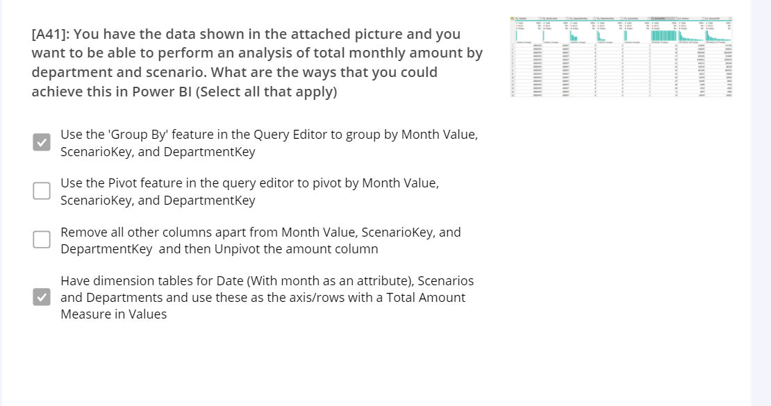

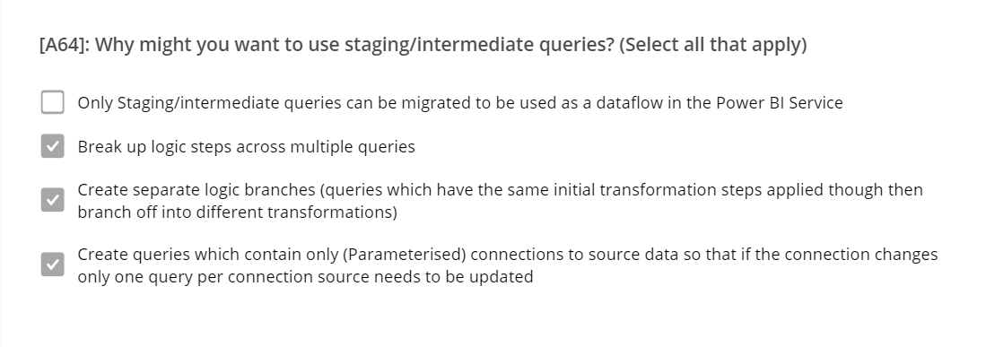

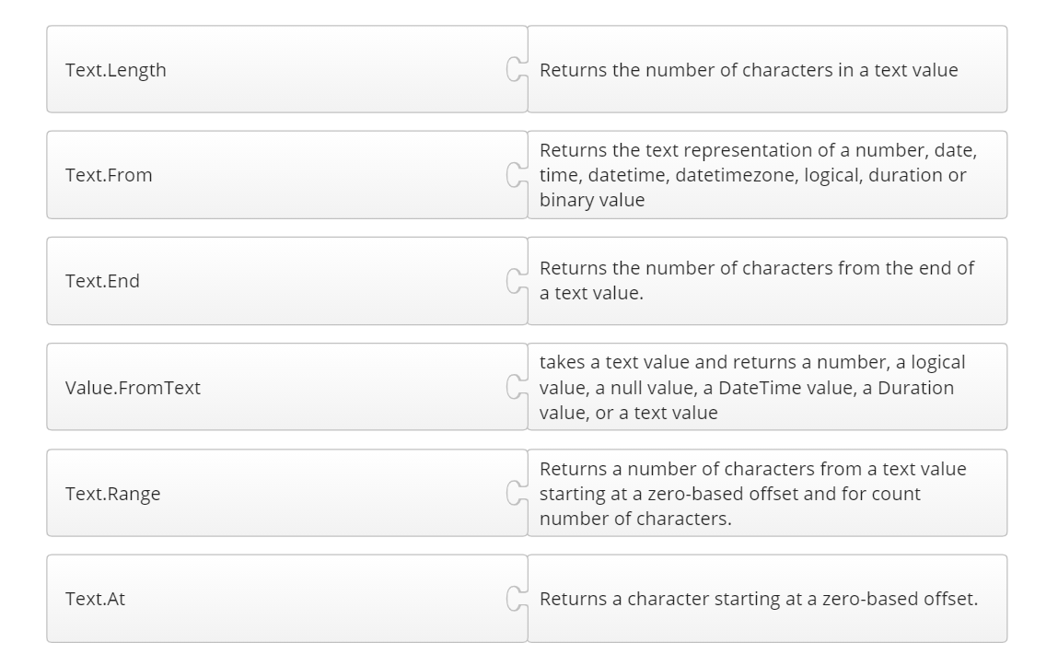

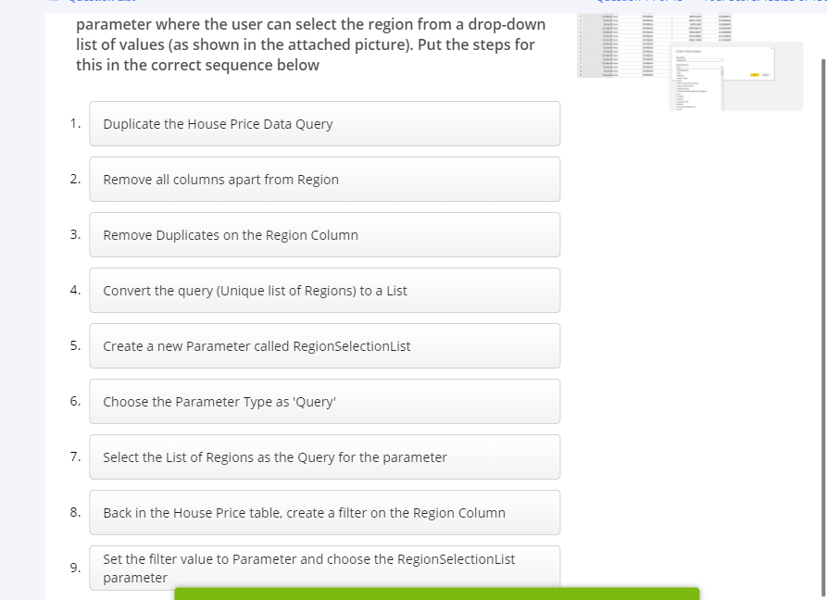

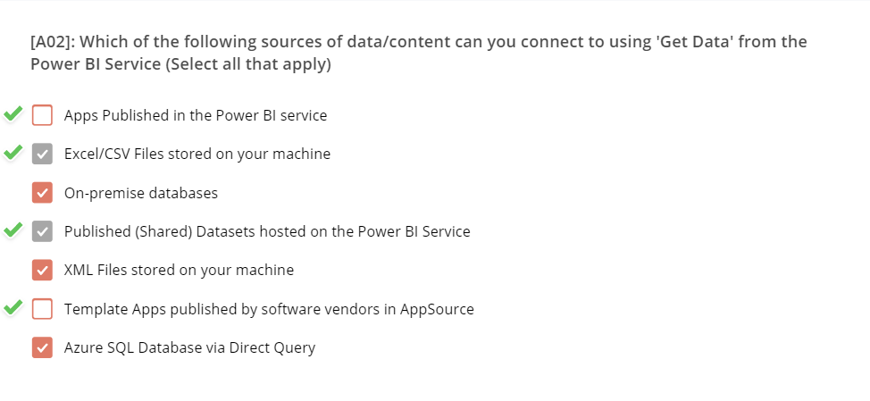

To analyze data, core components of analytics are divided into the following categories:

* Descriptive
* Diagnostic
* Predictive
* Prescriptive
* Cognitive

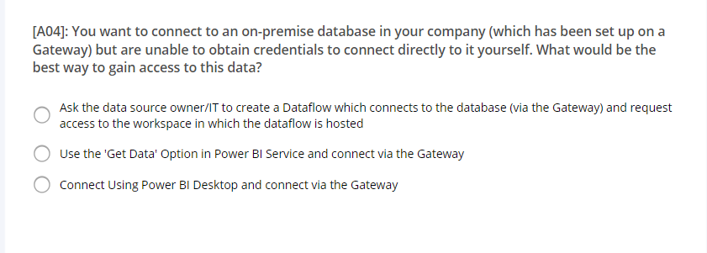

View this https://www.youtube.com/watch?v=jBP66FRatsY

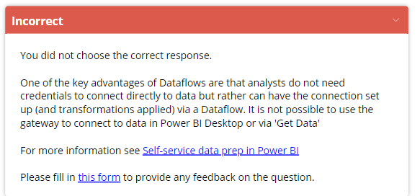

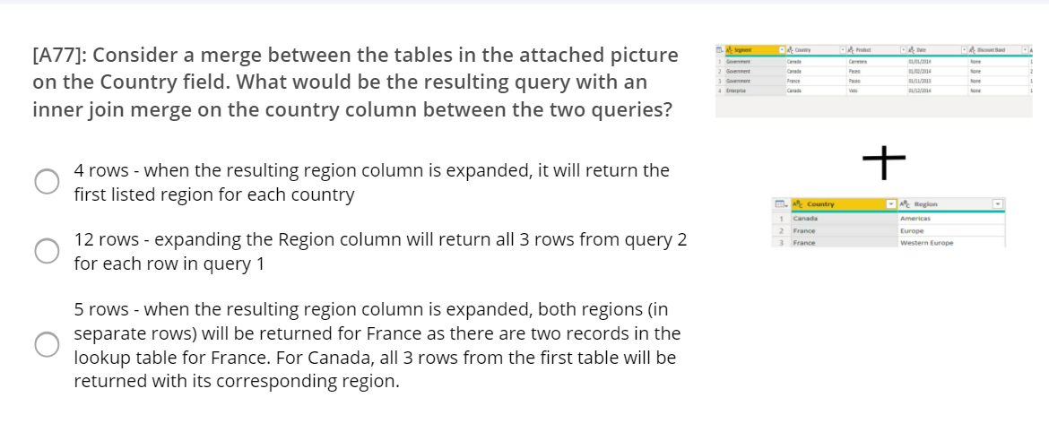

Once you’ve created a dataflow, you can use Power BI Desktop and the Power BI service to create datasets, reports, dashboards, and apps that leverage the power of the Common Data Model to drive deep insights into your business activities.

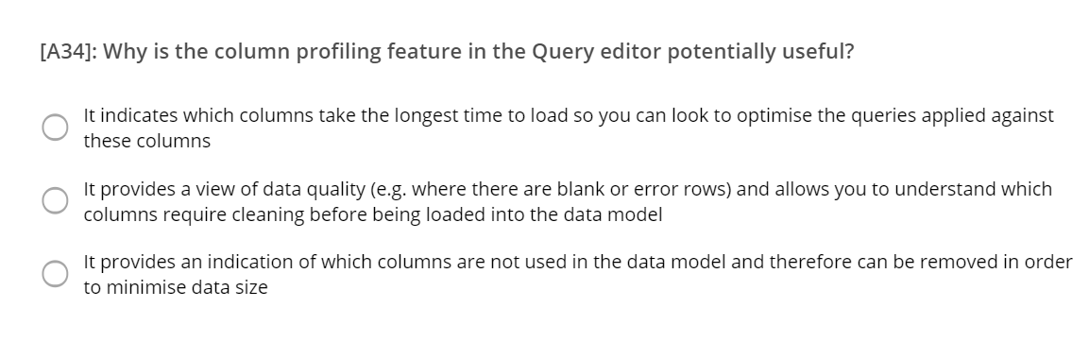

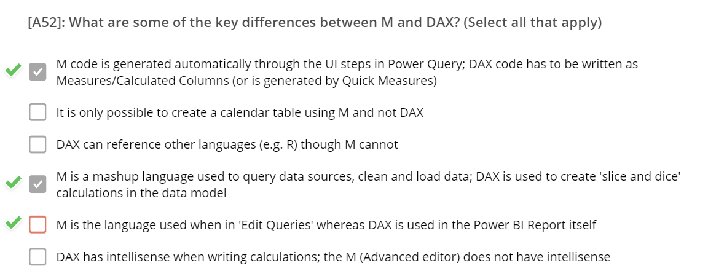

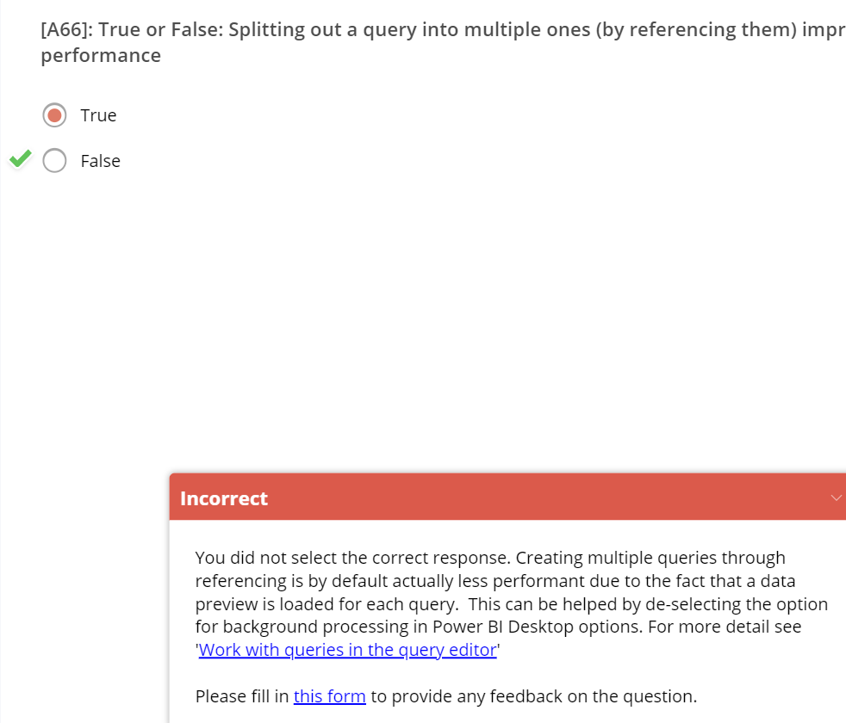

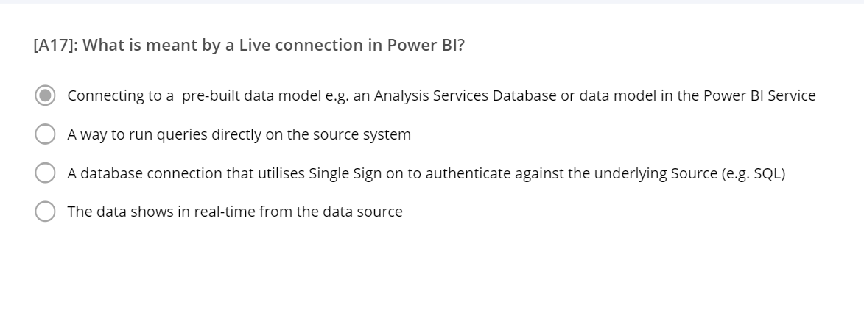

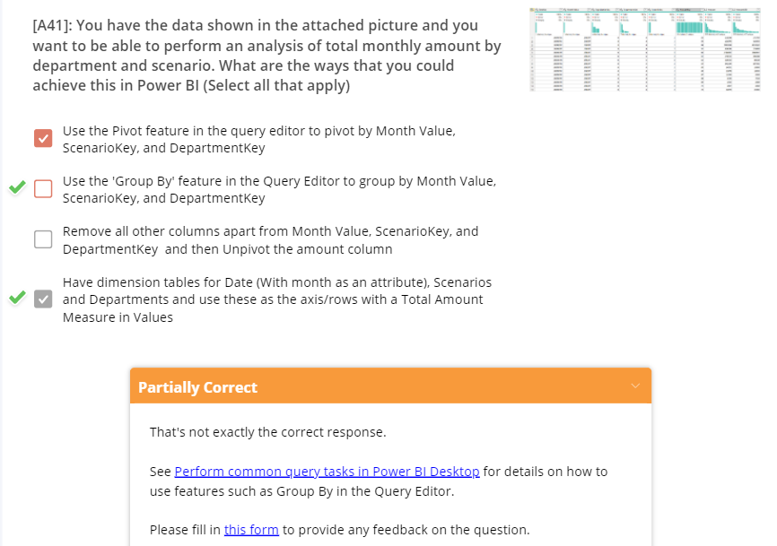

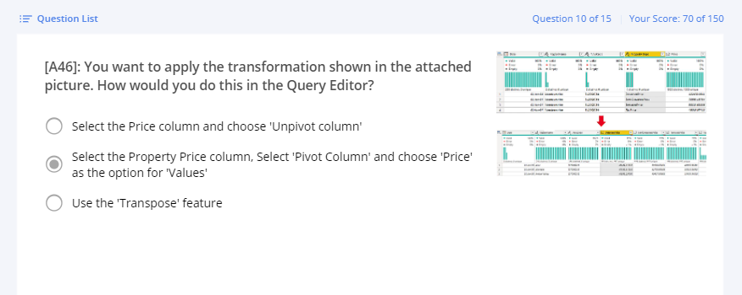

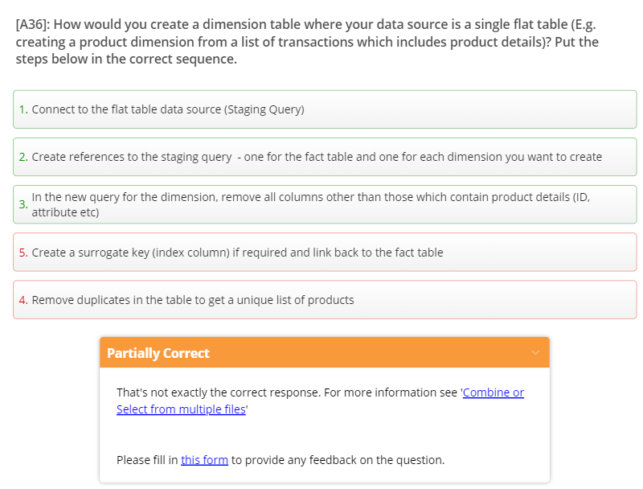

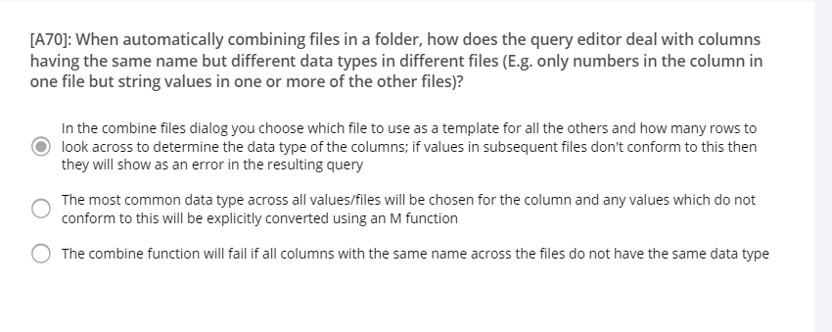

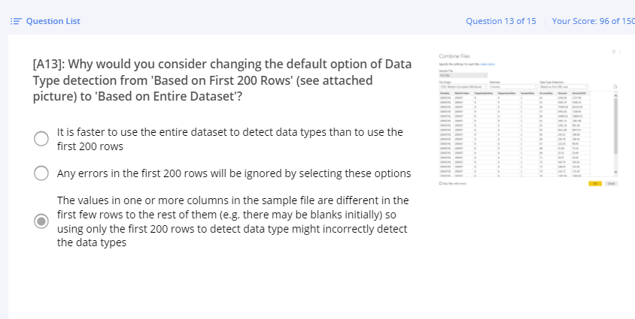

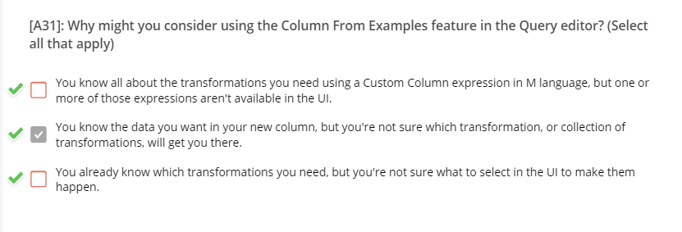

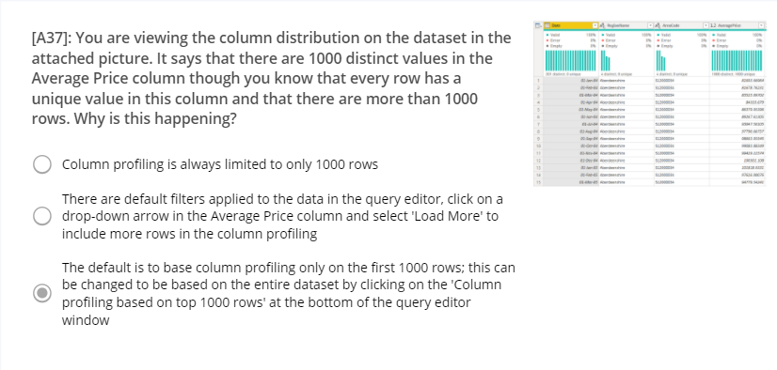

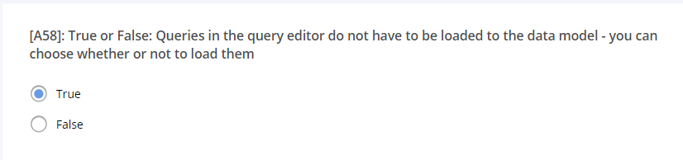

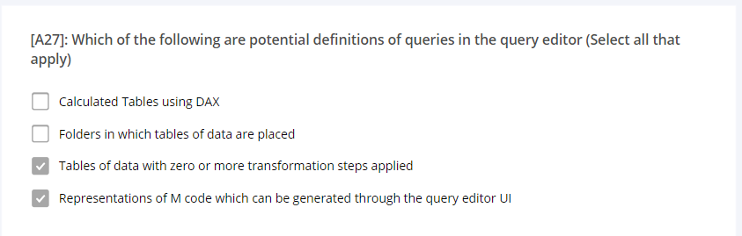

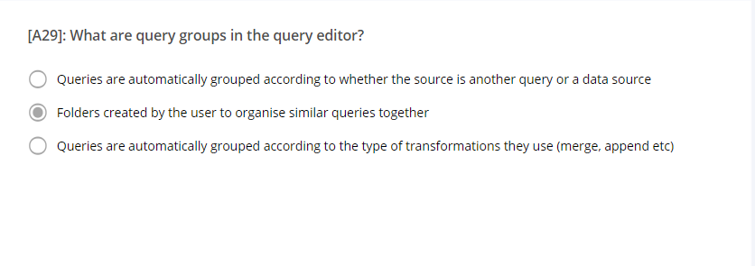



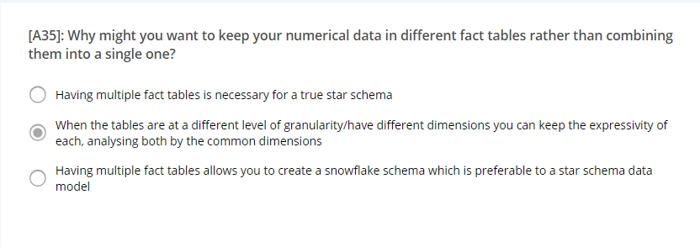

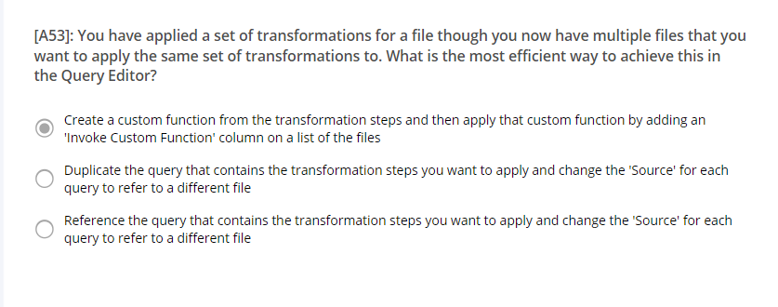

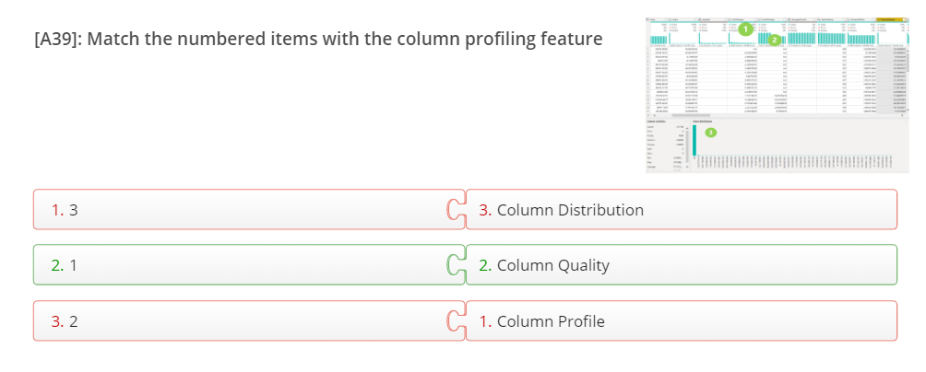

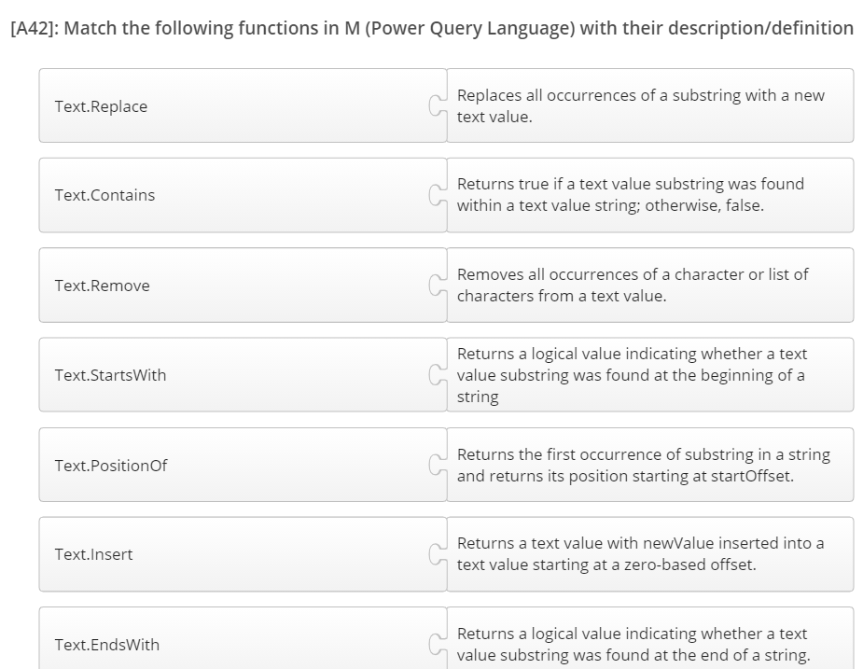

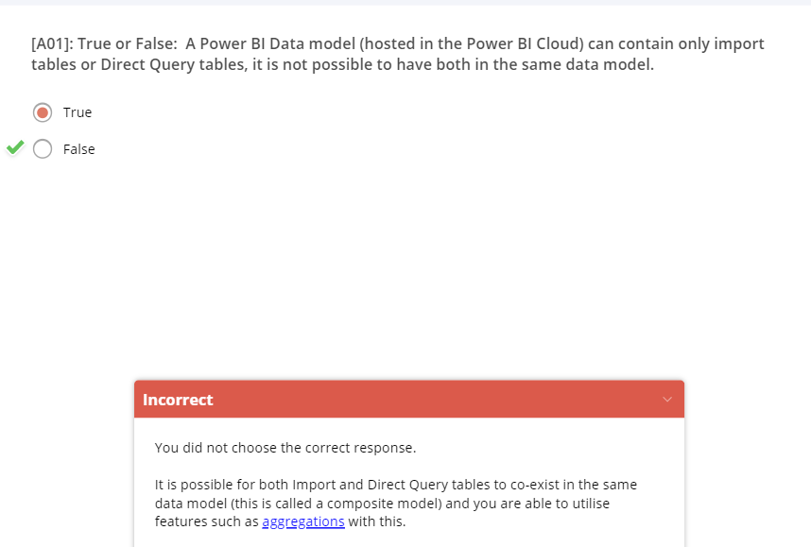

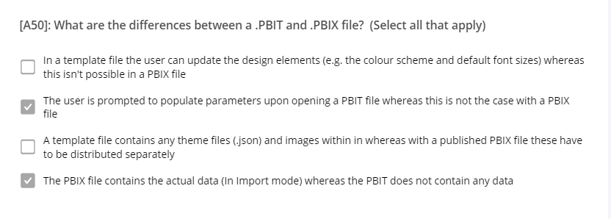

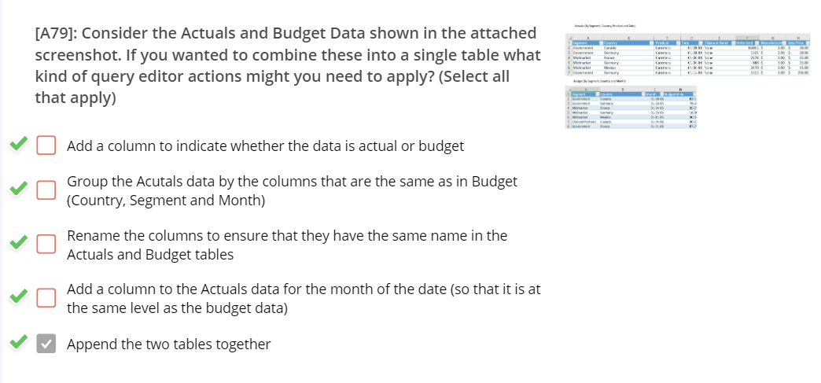wo

* **Better query performance over big data**. Every interaction with Power BI visuals submits DAX queries to the dataset. Cached aggregated data uses a fraction of the resources required for detail data, so you can unlock big data that would otherwise be inaccessible.

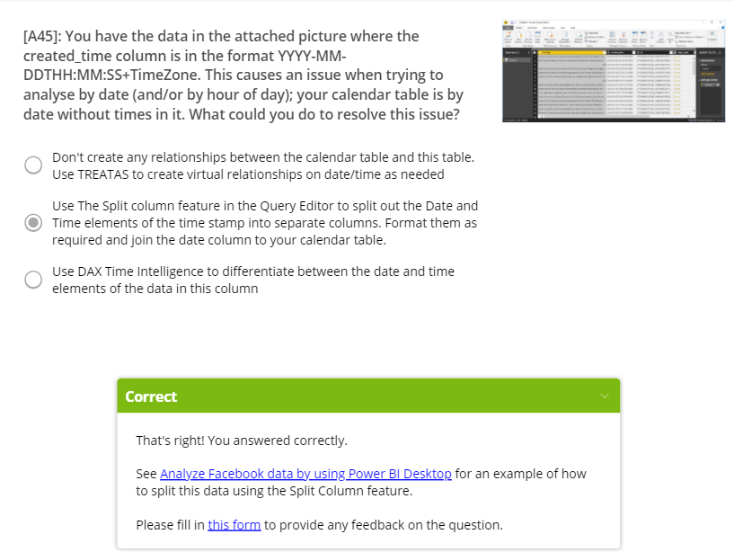

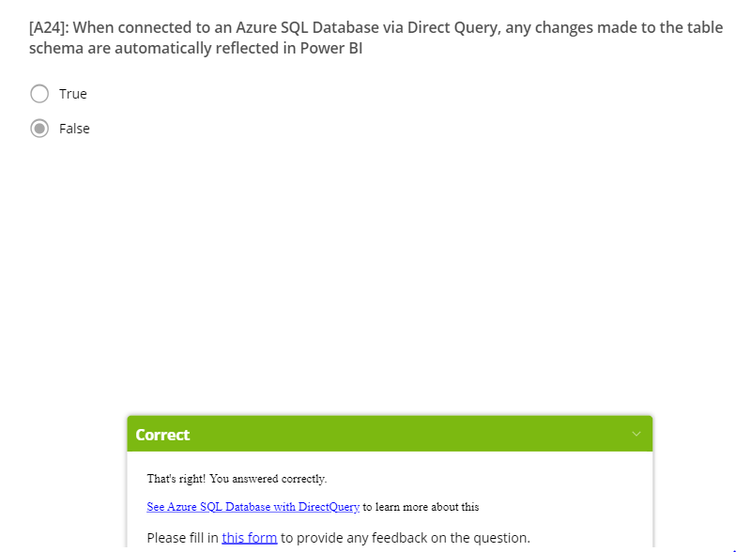

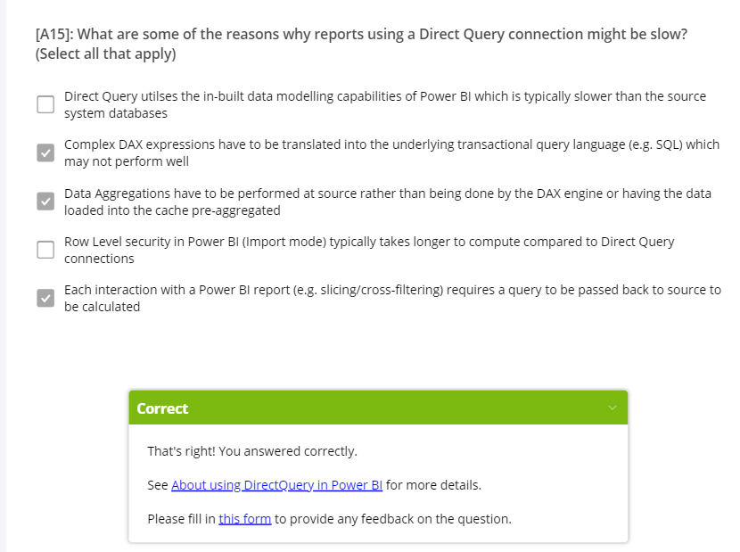

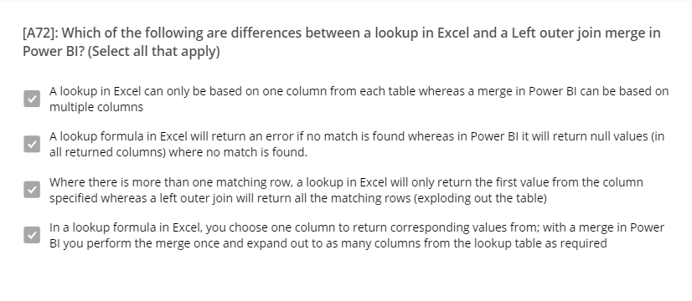

* If your goals can't be met by importing data, consider using DirectQuery. For example, if the data is changing frequently and reports must reflect the latest data, DirectQuery may be best. However, using DirectQuery is only feasible when the underlying data source can provide interactive queries, less than 5 seconds for the typical aggregate query, and can handle the query load that will be generated. Additionally, the list of limitations for the use of DirectQuery should be considered carefully.
* 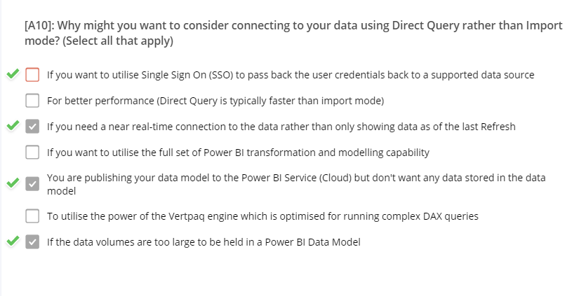

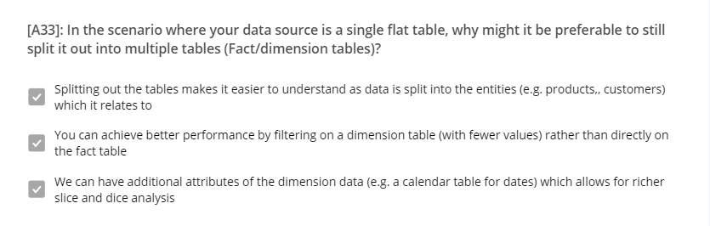

https://powerbi.microsoft.com/fr-fr/blog/deep-dive-into-query-parameters-and-power-bi-templates/

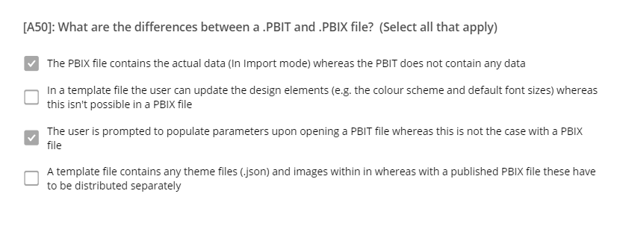

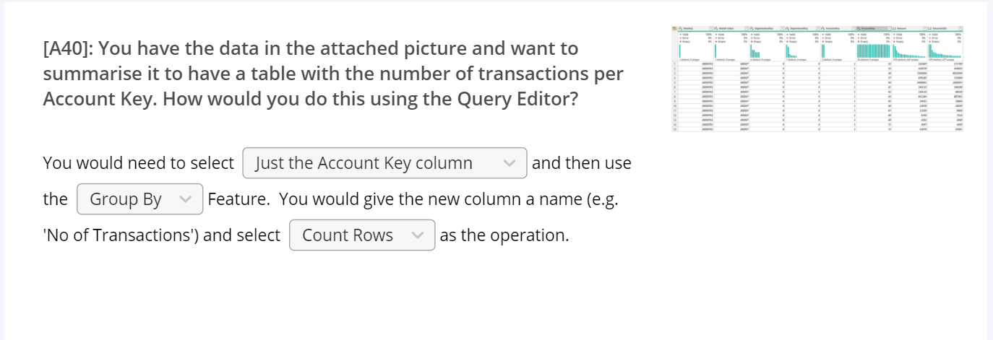

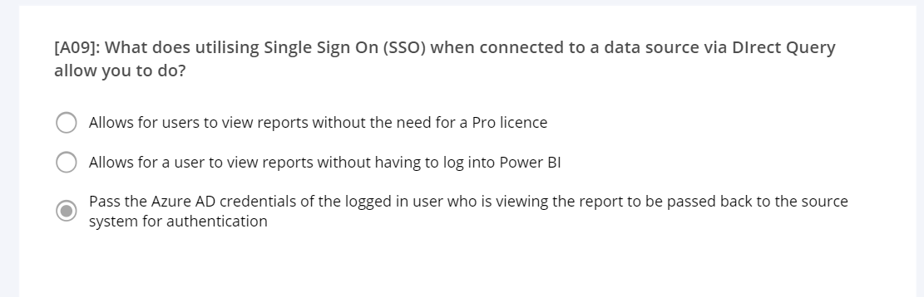

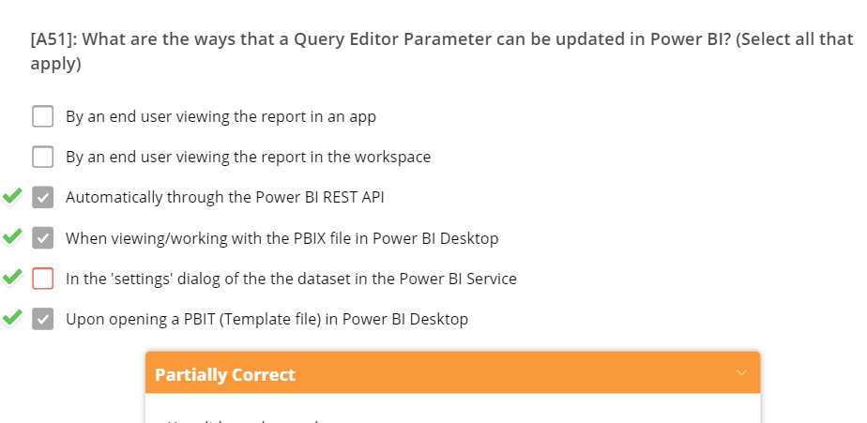

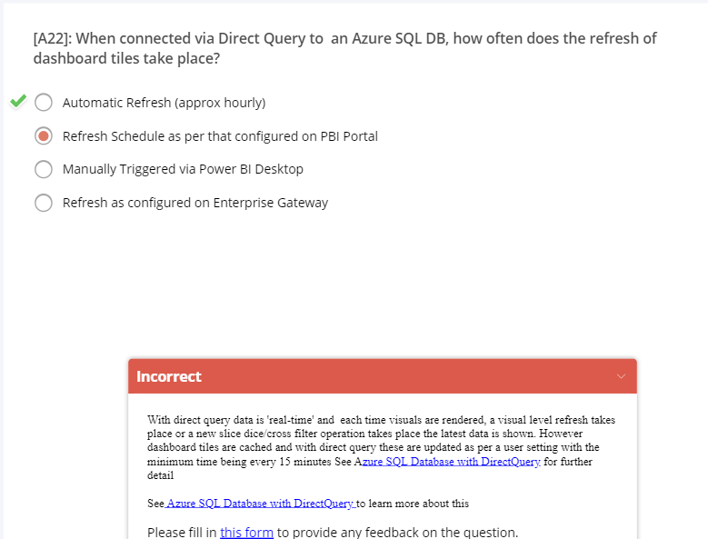

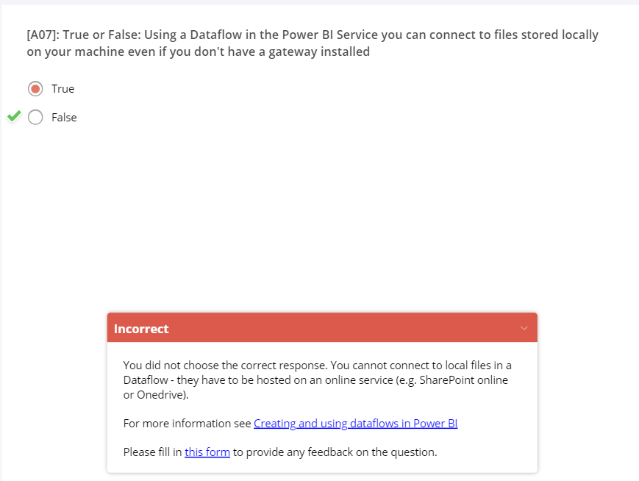

To keep all applied filters, in the **Drill-through** section of the **Visualizations** pane, set **Keep all filters** to **On**.

**Cross Filter – the two reports need to be in the same workspace**

**Pushing data to datasets**

The previous section described the three primary types of real-time datasets you can use in real-time streaming, and how they differ. This section describes how to create and push data into those datasets.

There are three primary ways you can push data into a dataset:

* Using the Power BI REST APIs
* Using the Streaming Dataset UI
* Using Azure Stream Analytics

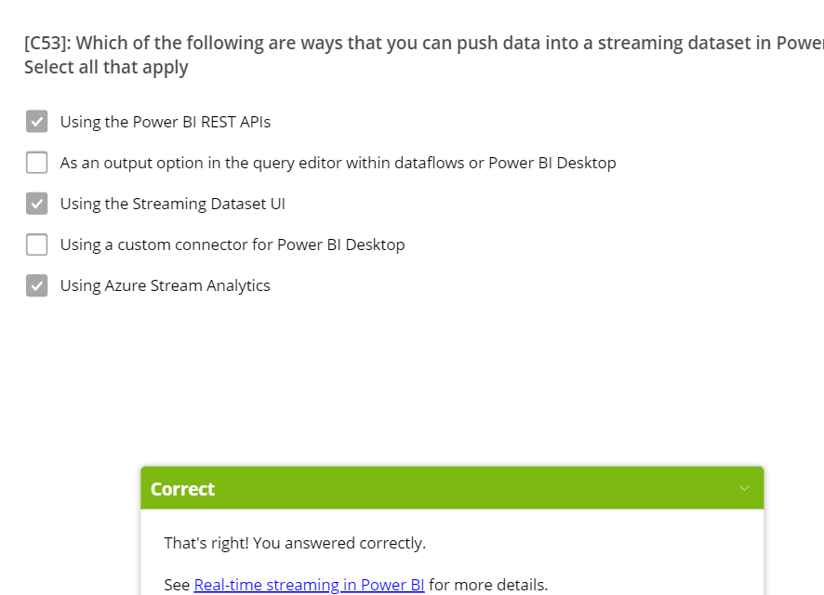

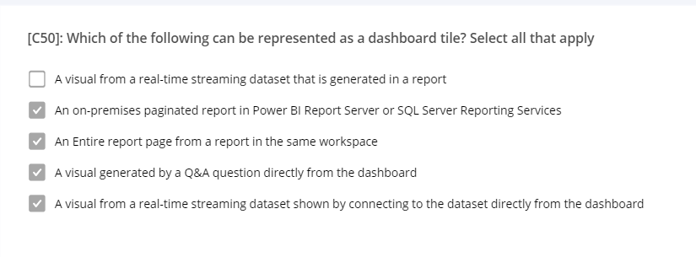

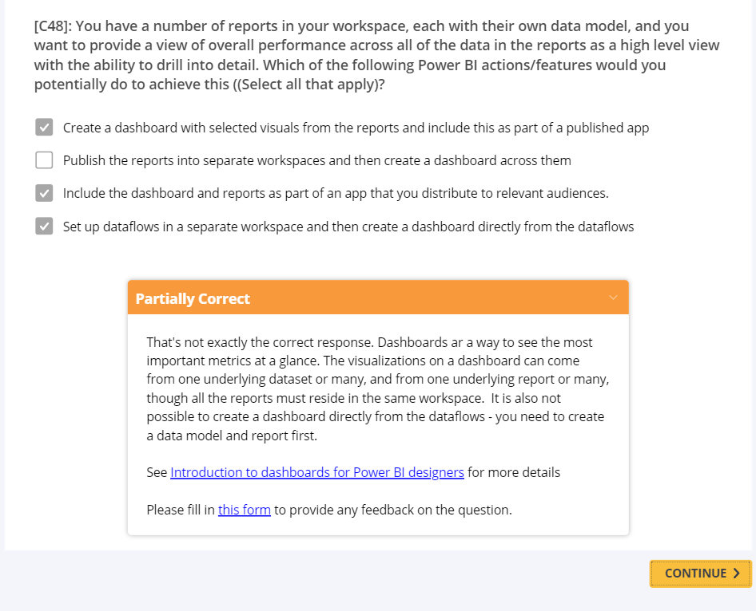

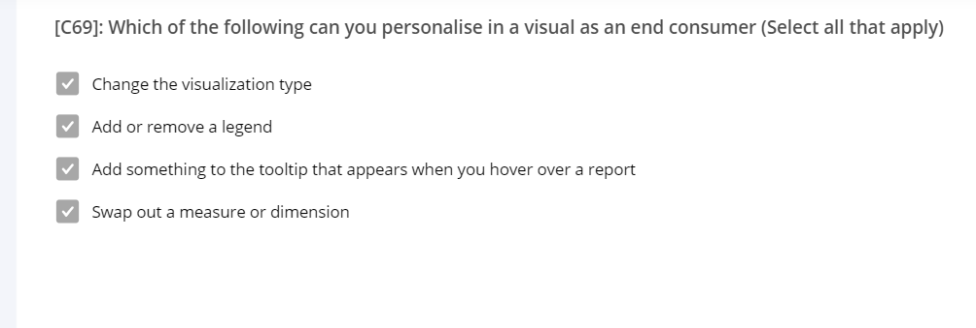

To keep all applied filters, in the **Drill-through** section of the **Visualizations** pane, set **Keep all filters** to **On**.

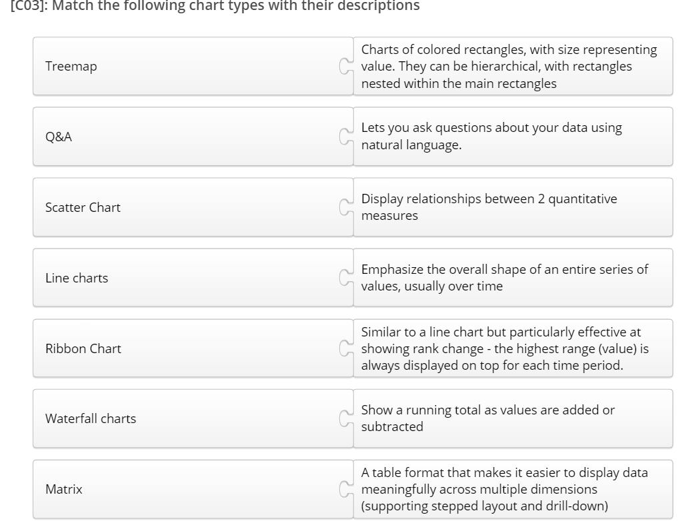

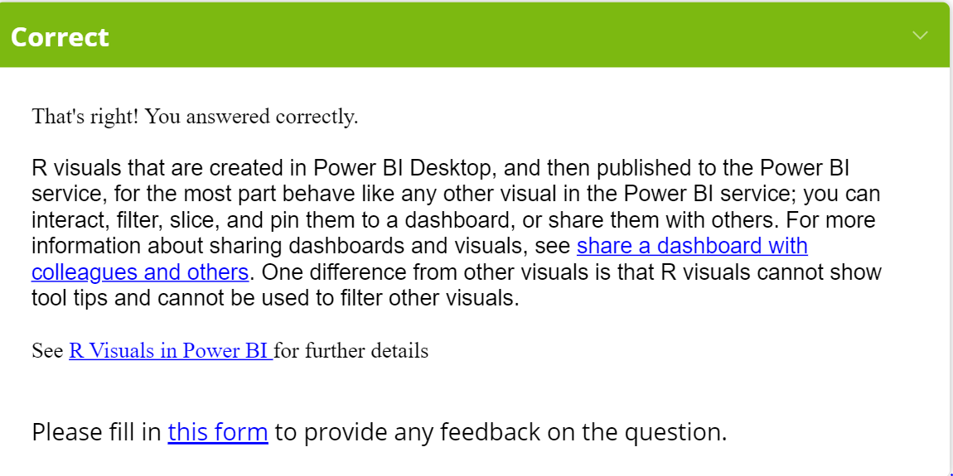

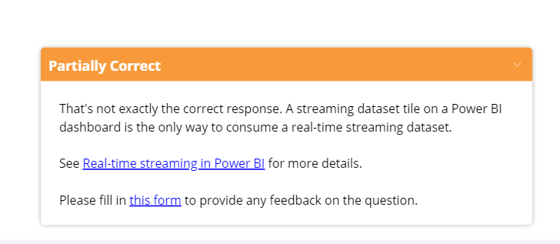

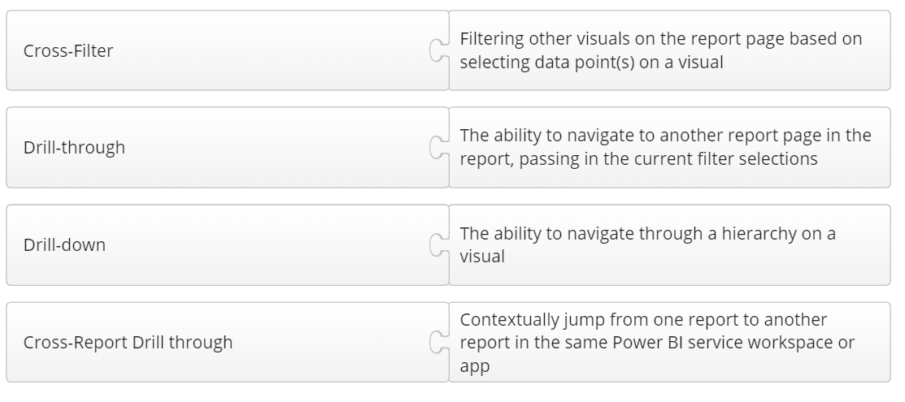

**STREAMING PUSH PUBNUB**

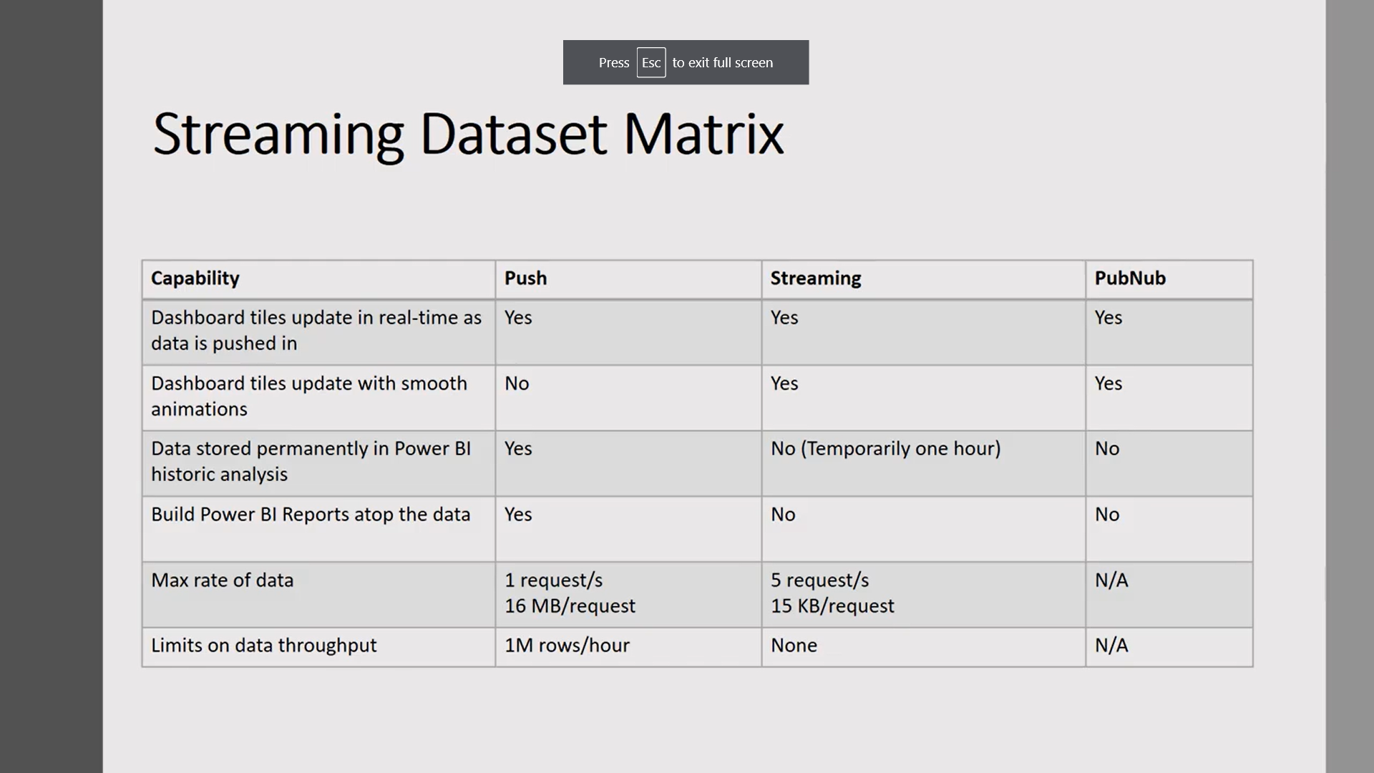

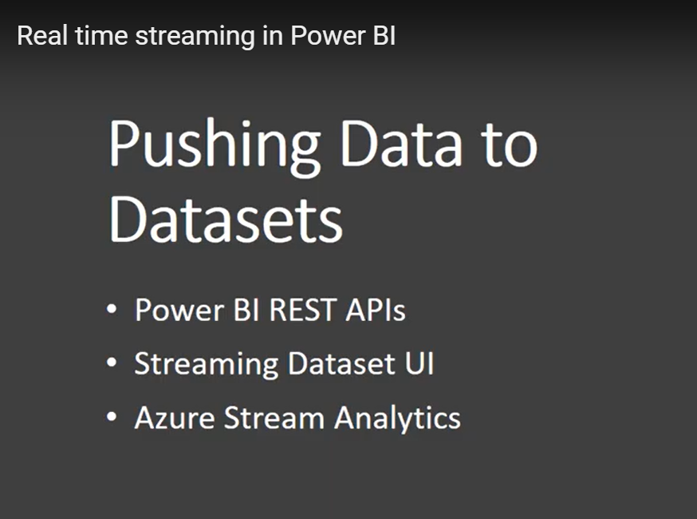

<https://www.youtube.com/watch?v=cOSKEWnlNkI>

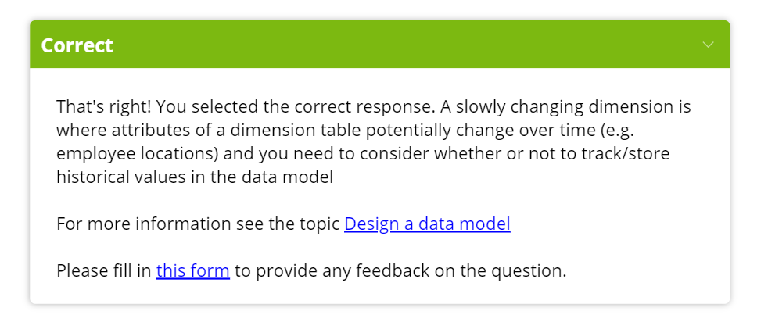

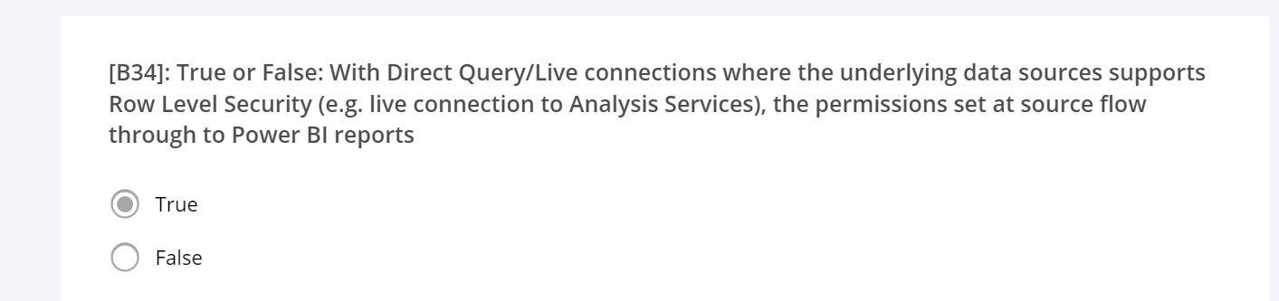

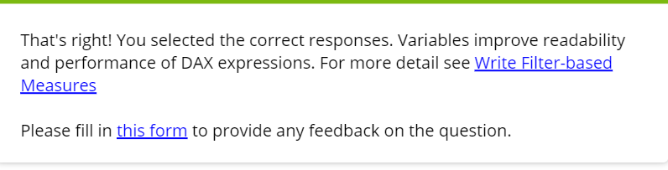

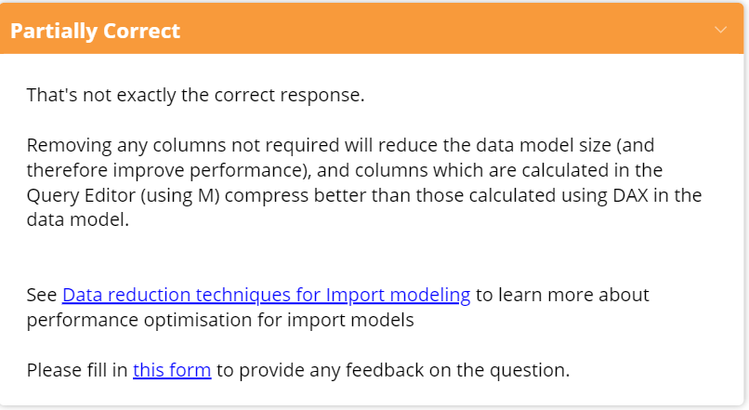

**Strong and Weak relationships**

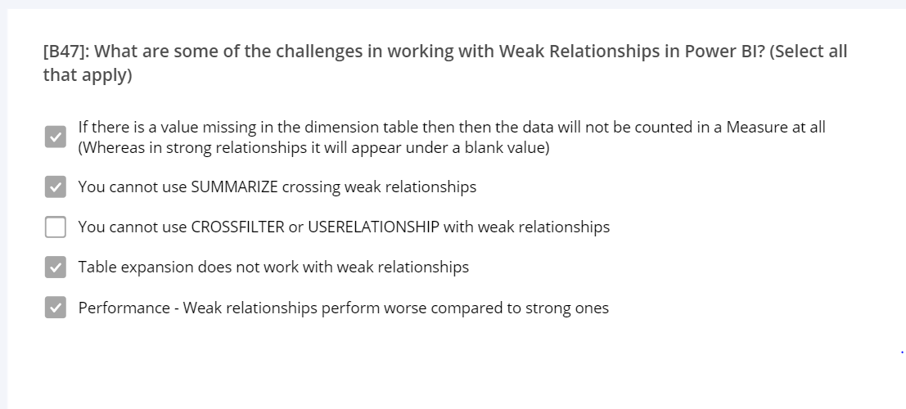

When two tables are linked through a strong relationship, the table on the one-side might contain the additional blank row in case the relationship is invalid. Thus, if the many-side of a strong relationship contains values that are not present in the table on the one-side, then [a blank row is appended to the one-side table](https://www.sqlbi.com/articles/blank-row-in-dax/). The additional blank row is not added to the target of a weak relationship.

The most complex scenario happens with cross-island relationships. A cross-island relationship links two tables that are stored in different data sources. As such, the relationship needs to be resolved by the DAX formula engine, which will read the relevant information from the two data sources and then join the tables. A cross-island relationship is the first kind of weak relationship.

Therefore, a relationship is weak if it has a many-to-many cardinality or if it is a cross-island relationship.\

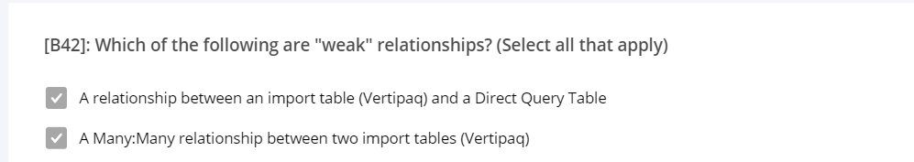

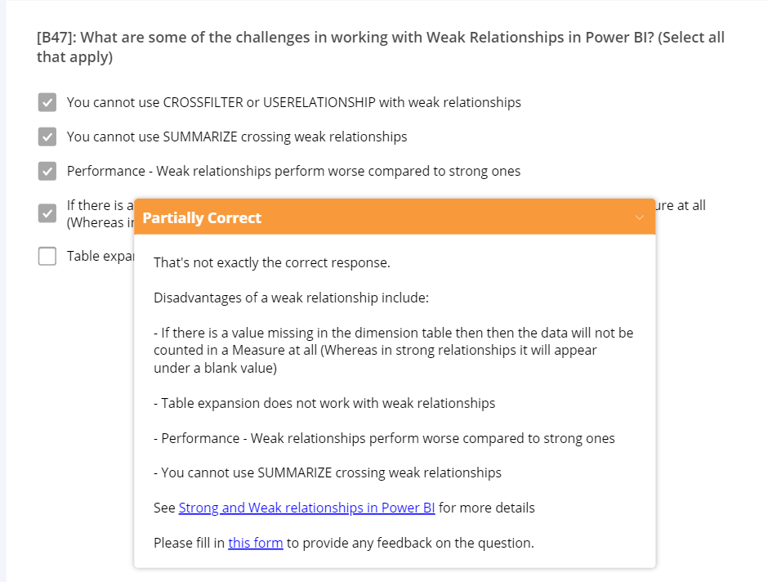

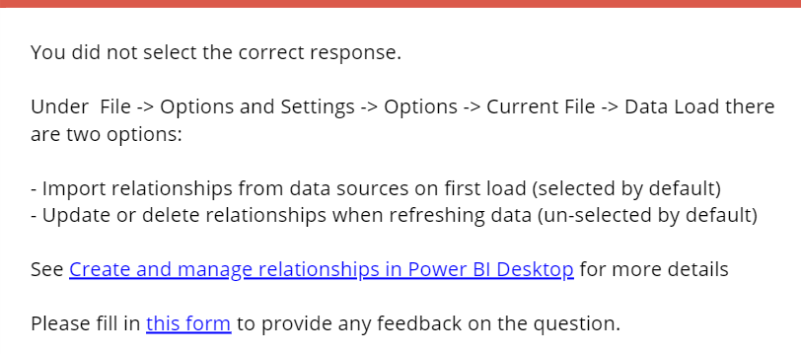

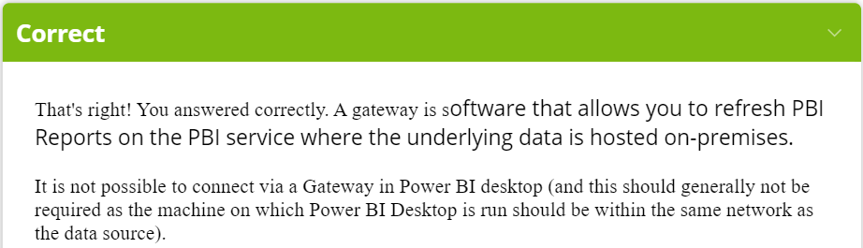

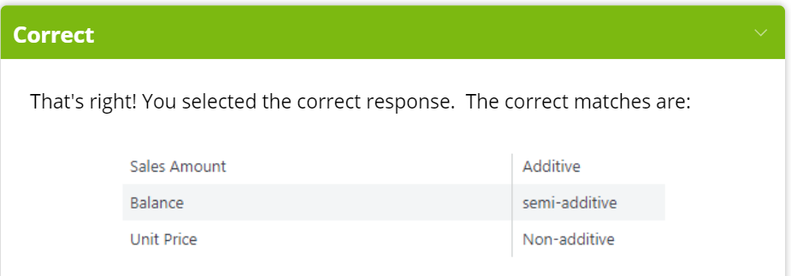

Deployment Pipeline

### Connect different stages to different databases

A production database should always be stable and available. It's better not to overload it with queries generated by BI creators for their development or test datasets. Build separate databases for development and testing. This helps protect production data, and doesn't overload the development database with the entire volume of production data, which can slow down things.

### Use parameters in your model

As you can't edit datasets data sources in Power BI service, we recommend using [parameters](https://docs.microsoft.com/en-us/power-query/power-query-query-parameters) to store connection details such as instance names and database names, instead of using a static connection string. This allows you to manage the connections through the Power BI service web portal, or [using APIs](https://docs.microsoft.com/en-us/rest/api/power-bi/datasets/updateparametersingroup), at a later stage.

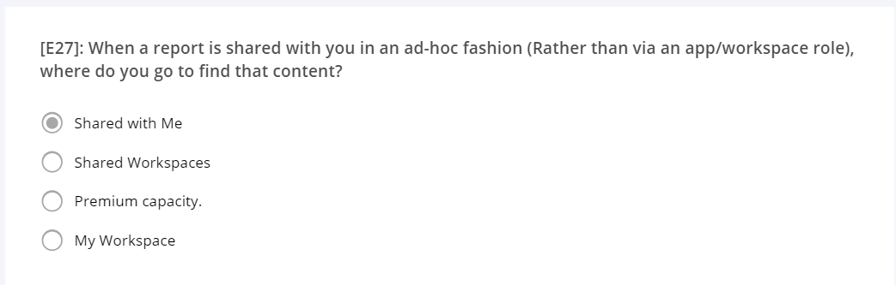

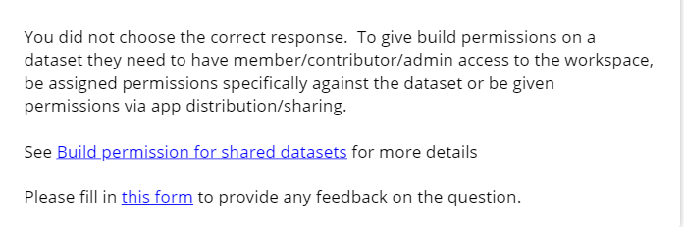

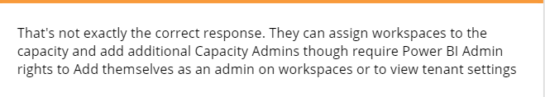

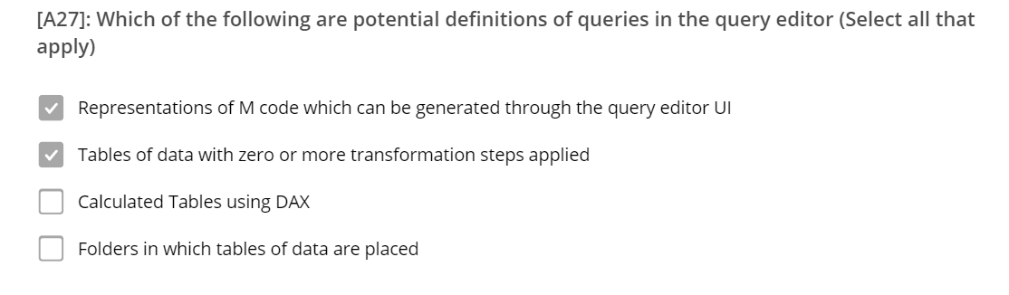

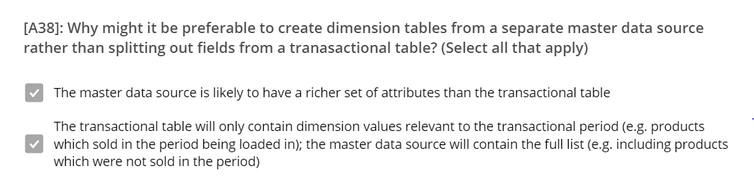

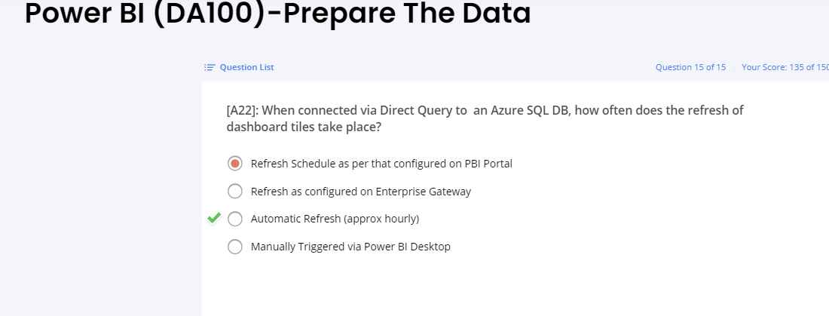

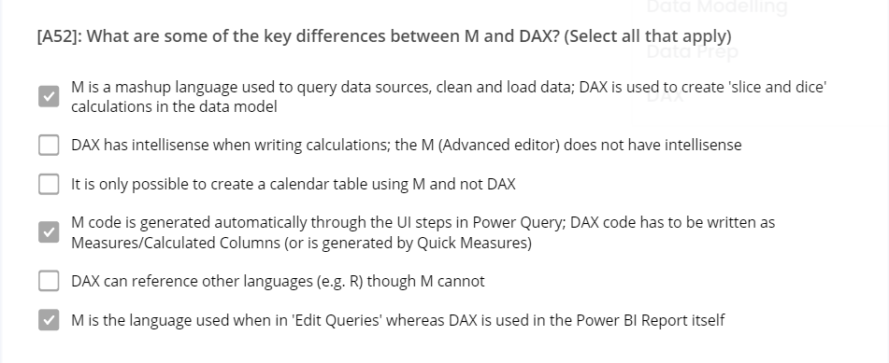

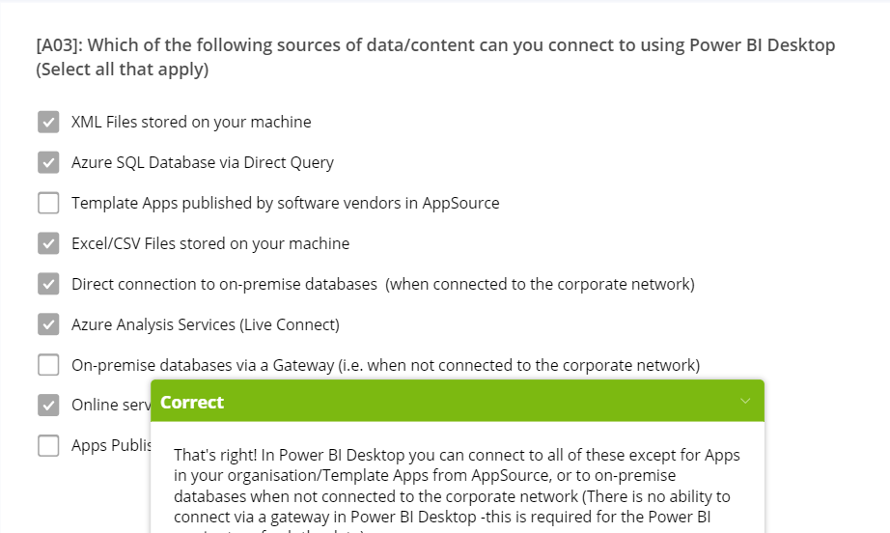

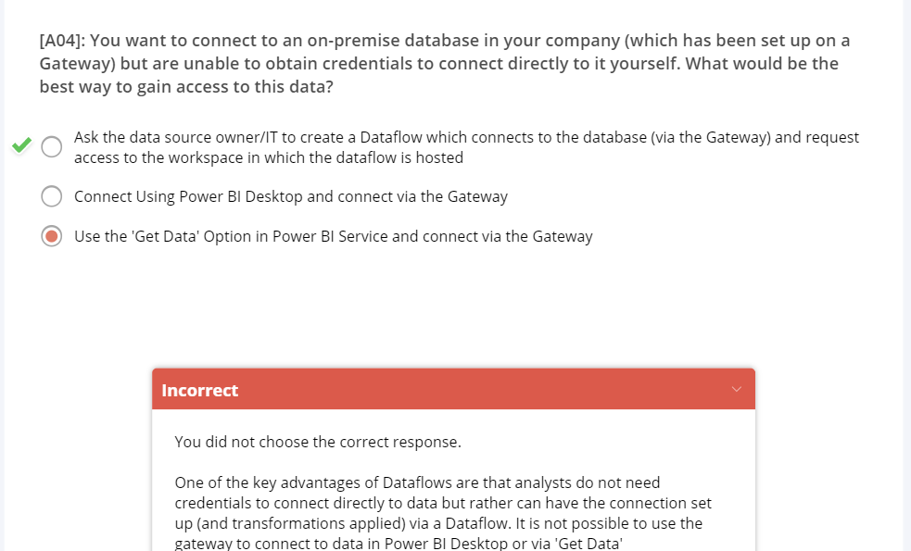

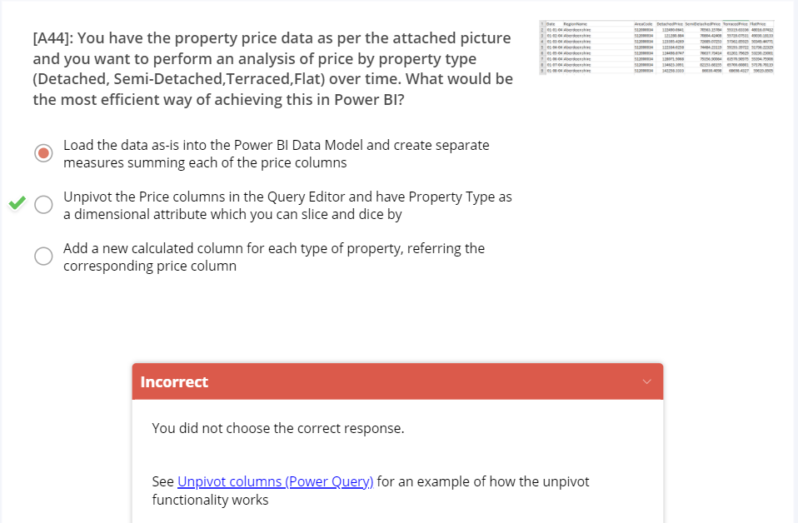

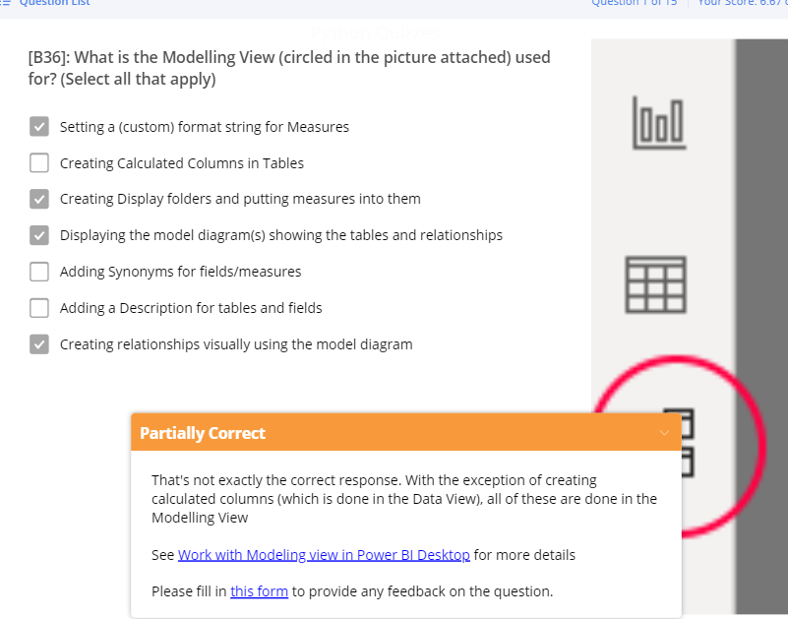

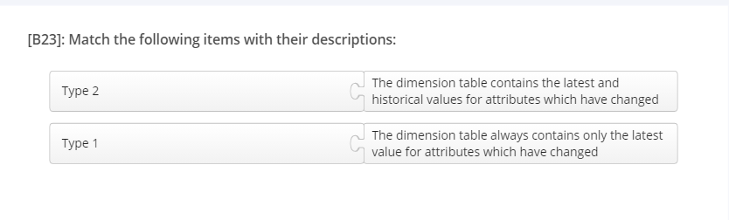

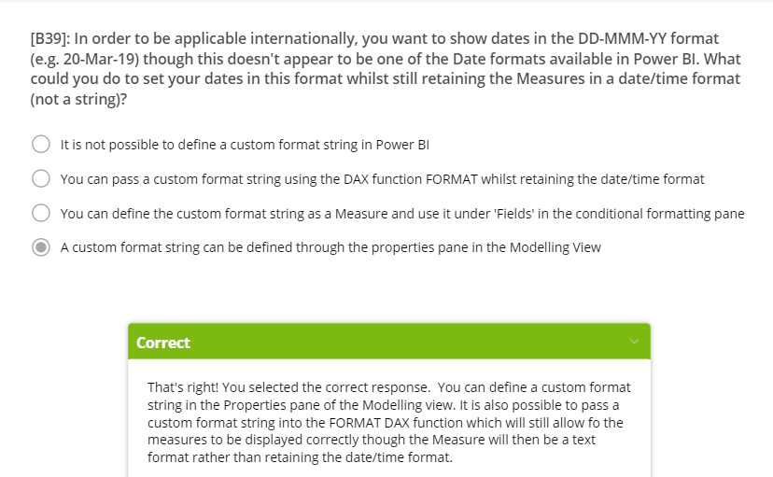

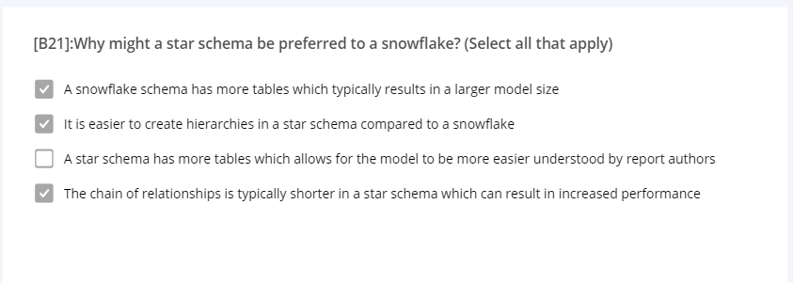

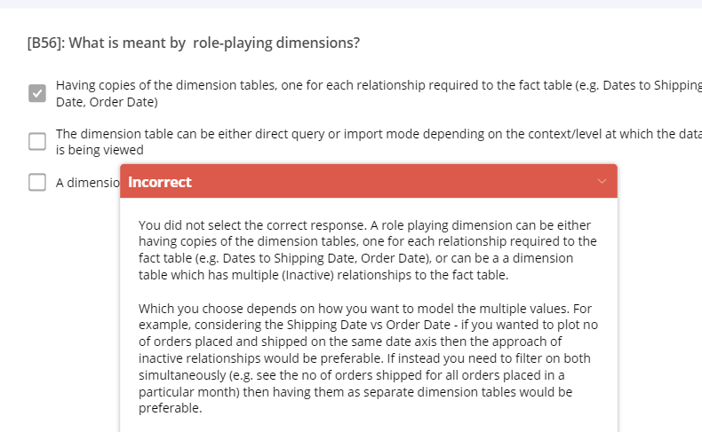

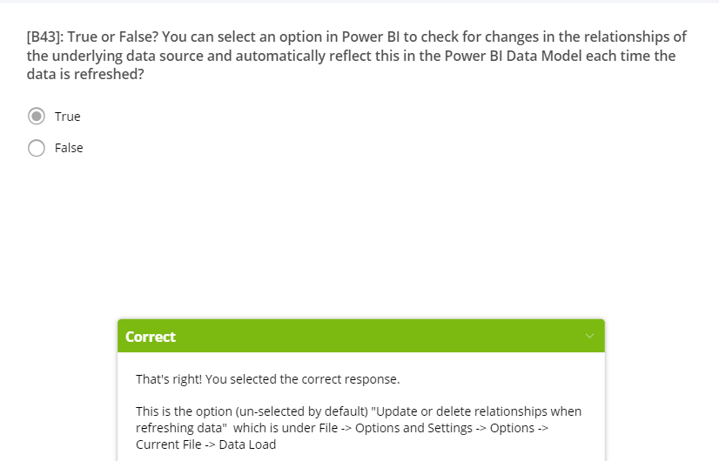

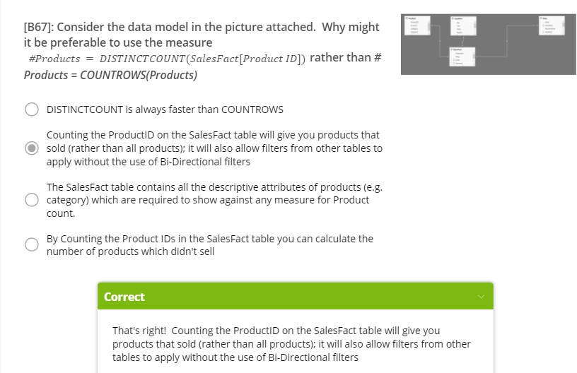

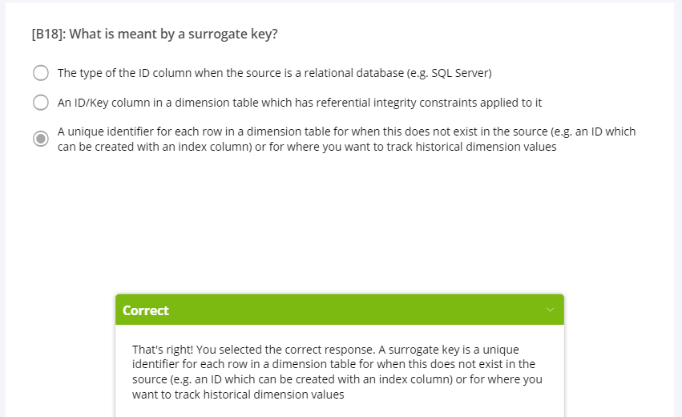

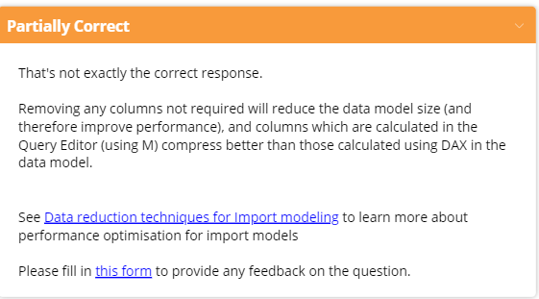

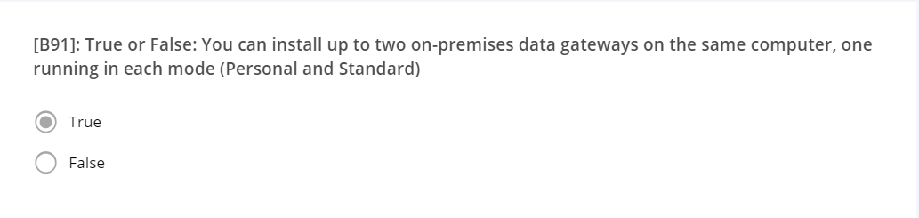

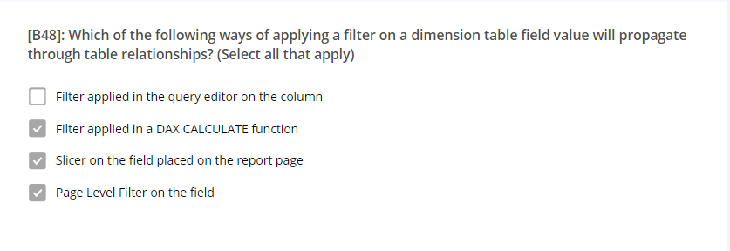

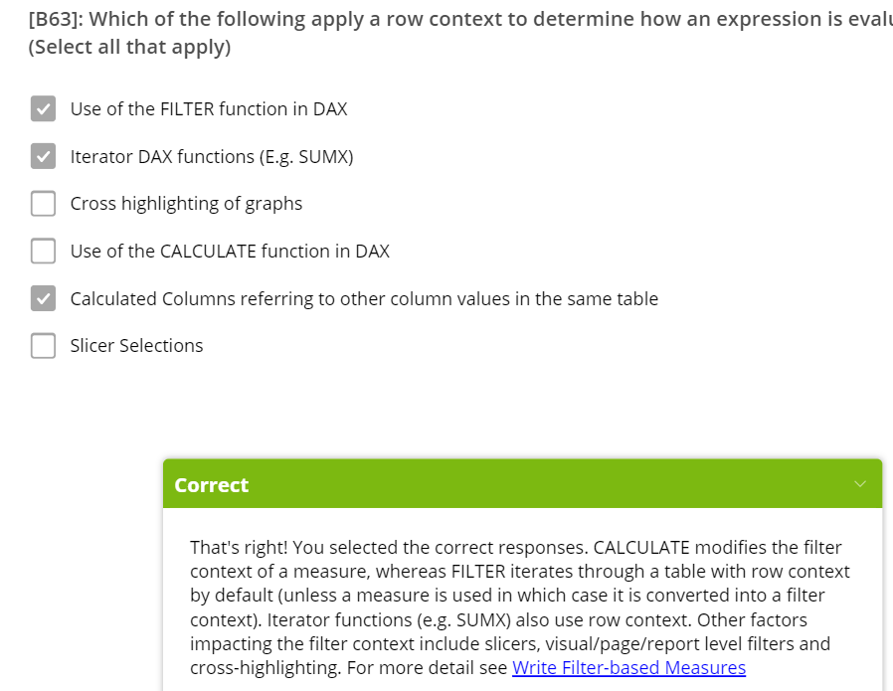

**ROW LEVEL SECURITY**

There are two ways to implement row-level security in Power BI: the static method and the dynamic method.

Row-level security (RLS) uses a DAX filter as the core logic mechanism. This module will demonstrate how you can implement row-level security in Power BI using DAX to ensure that only the appropriate person is seeing the appropriate records.

**STATIC RLS**

**Create role**

**Create DAX filter**

**Assign users or security groups to roles**

**DYNAMIC RLS**

**Create roles but access is limited to the user within the role**

**Data Accessed is as per a User column next to each row in the data table**

**Managing datasets**

This sharing of datasets needs to be actively managed for optimal organizational performance. For example, you can automate the refresh process, so that it becomes more efficient and users always have access to the latest data. You can also promote certain datasets over others, so users can clearly identify the best datasets to use.

The management of datasets also involves the implementation of clever parameters within those datasets, to aid decision making and solve business problems. For example, you can use parameters change the server or database name of your dataset, or a file path for a data source. You can also use parameters to configure incremental refreshes of your data, and to run 'what-if' scenarios and conduct scenario type analysis on the data.

Another key area of dataset management is setting up and maintaining a gateway, so you and other users can access your on-premises data source from the cloud.

**If you are using bidirectional relationships, it is important to note that RLS ‘by default’ only go in one direction.**

 ensure **Query1** doesn't show up in the field list for the report, which could potentially confuse end-users, you can disable it loading in the report. Right-click **Query1** again, then select **Enable load** (selected by default) to disable the feature.

**If Cross-filter both is on, Click Apply Security Filter I Both Directions**

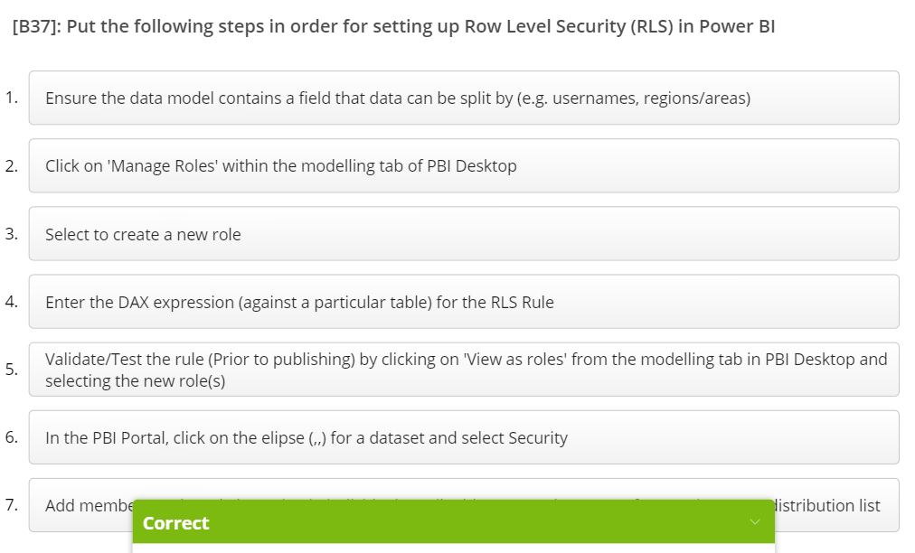

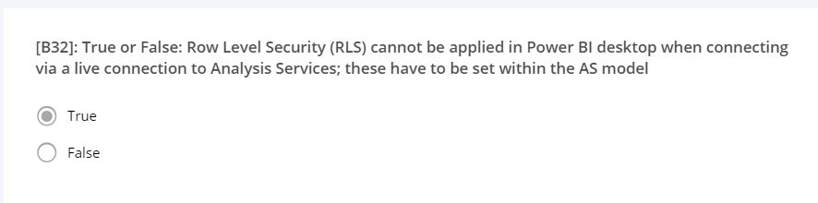

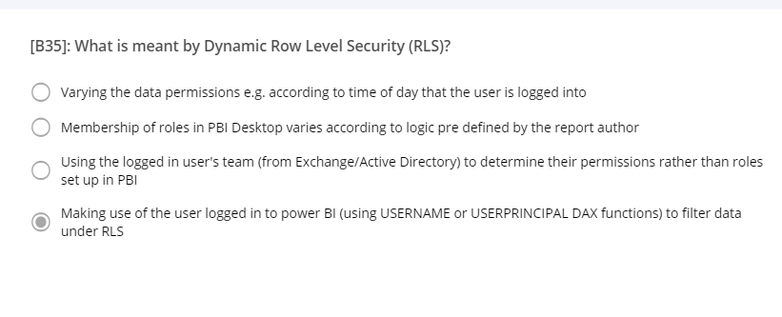

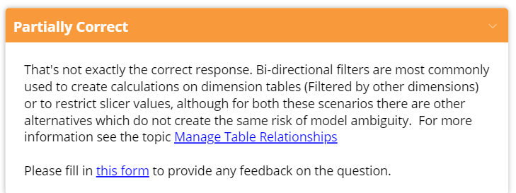

CALCULATETABLE versus FILTER

<http://www.learndatainsights.com/topic/write-filter-based-measures/>

# Products Not sold =  
VAR NotSoldFilter =  
    FILTER ( ‘Product’, COUNTROWS ( RELATEDTABLE ( SalesFact ) ) = 0 )  
RETURN  
    CALCULATE ( COUNTROWS ( Product ), NotSoldFilter )

CALCULATETABLE wouldn’t work in this case (it would come up with the error The True/False expression does not specify a column. Each True/False expressions used as a table filter expression must refer to exactly one column).

In addition, FILTER is required when a measure is used as a filter condition. For example we could define a measure

# Sales =  
COUNTROWS ( SalesFact )

and then define the Products Not Sold Measure as:

# Products Not sold v2 =  
VAR NotSoldFilter =  
    FILTER ( ‘Product’, [# Sales] = 0 )  
RETURN  
    CALCULATE ( COUNTROWS ( ‘Product’ ), NotSoldFilter )

Which would return the same result and, at least for more complex measures, is a convenient way to apply filters. Any time a measure is used as a filter condition, the FILTER function (Rather than CALCULATETABLE) needs to be used.

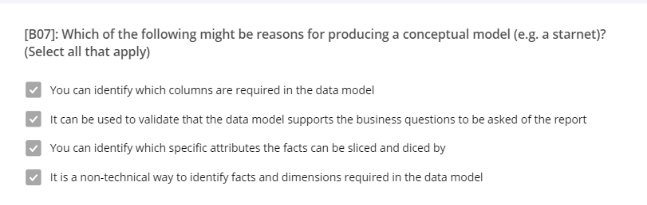

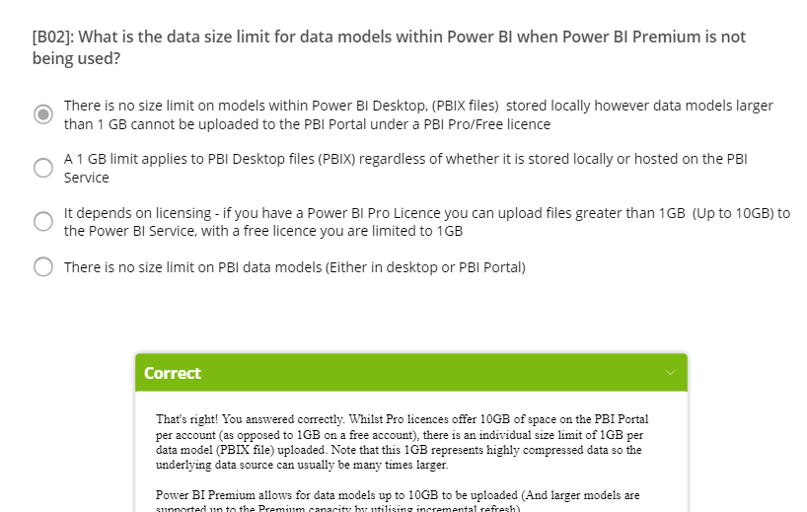

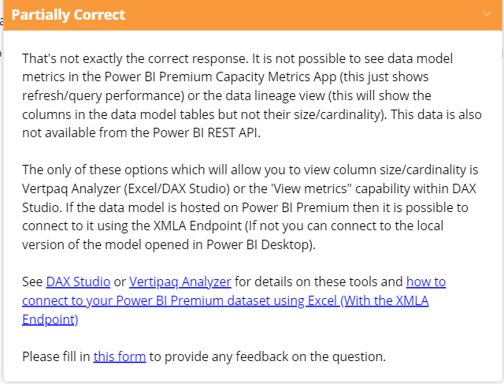

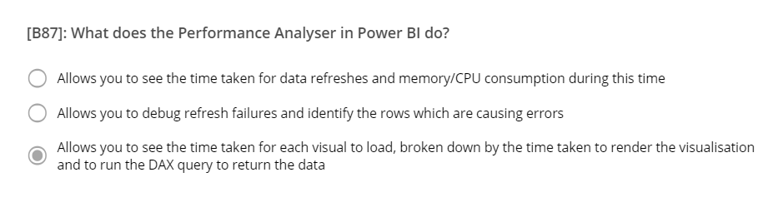

**MEASURES BUILD**

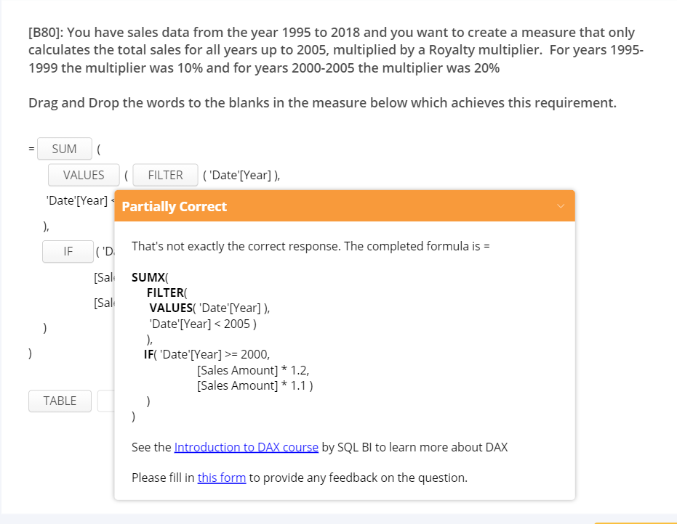

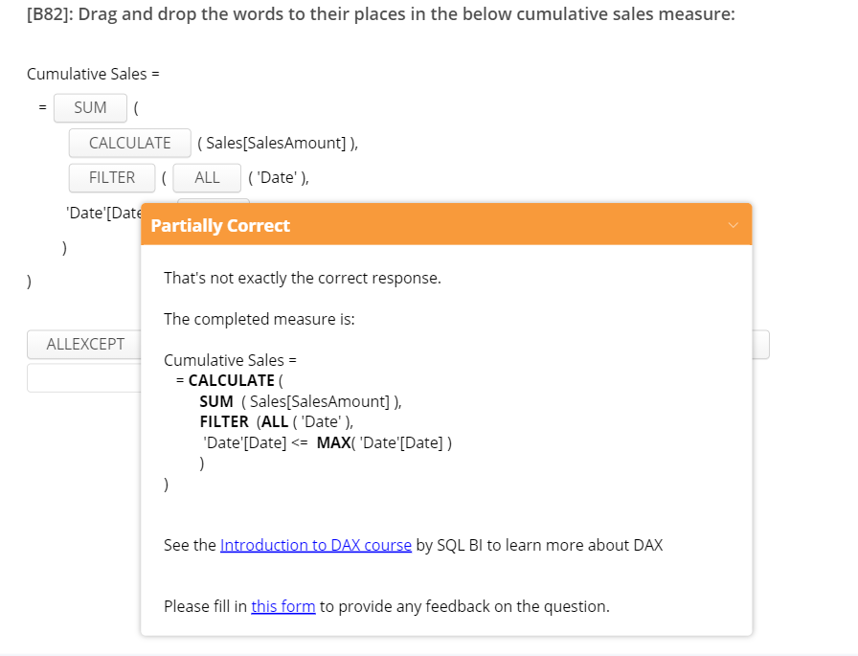

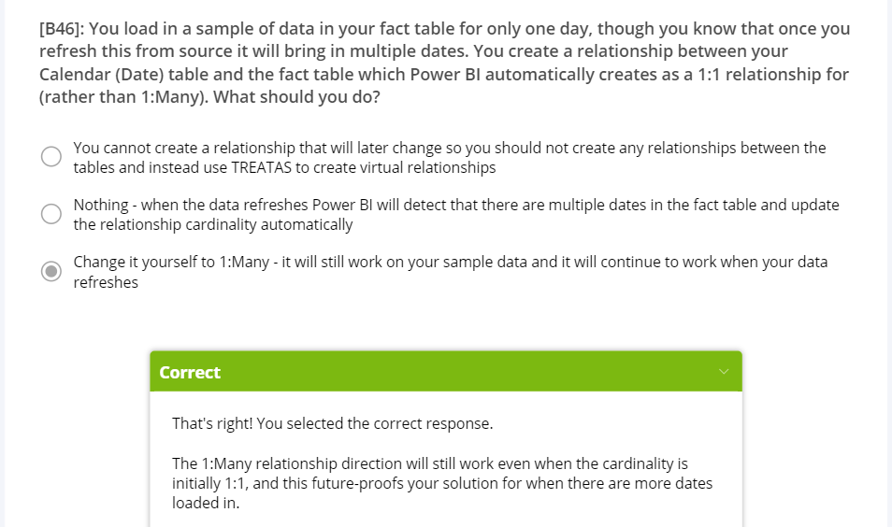

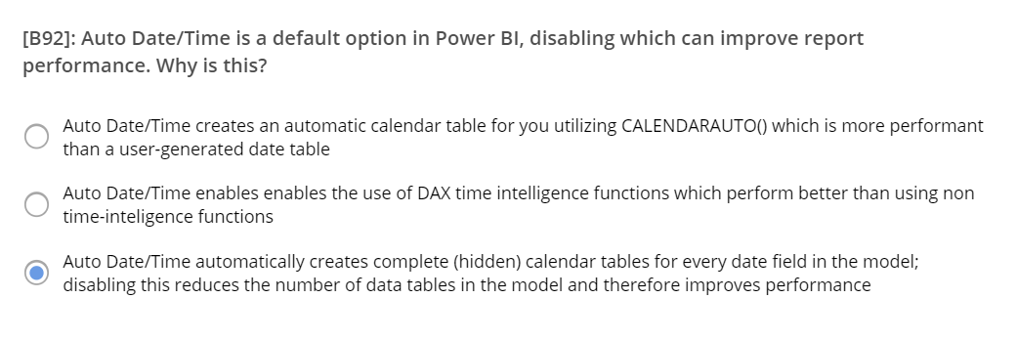\\

**Surrogate Key**

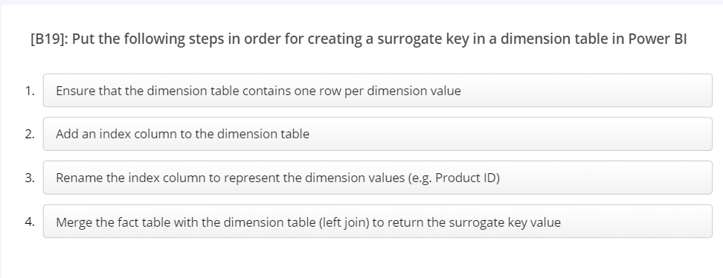

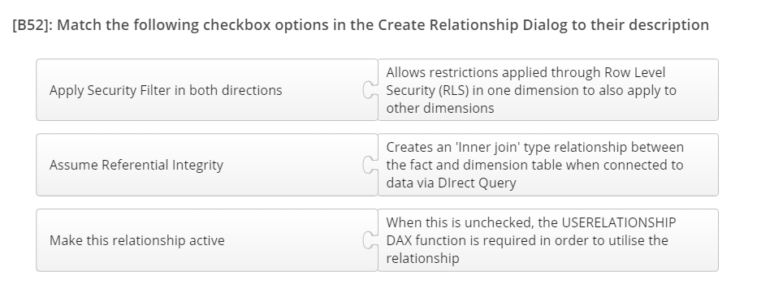

**VISUALIZATION**

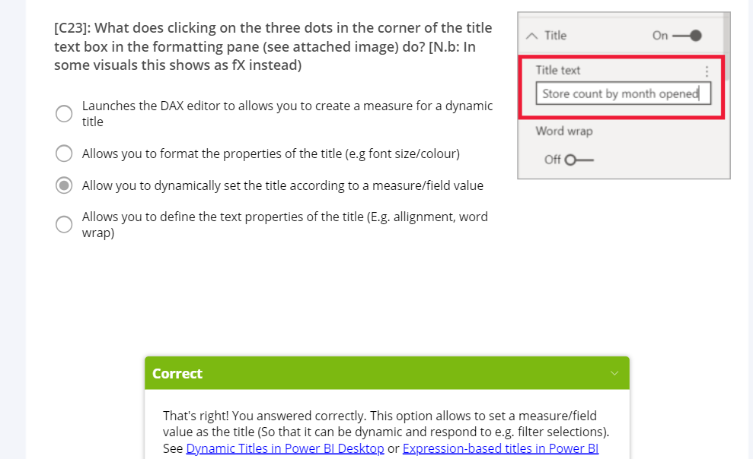

SWITCH (

USERCULTURE(),

"de-DE", “Umsatz nach Produkt”,

"fr-FR", “Ventes par produit”,

“Sales by product”

)

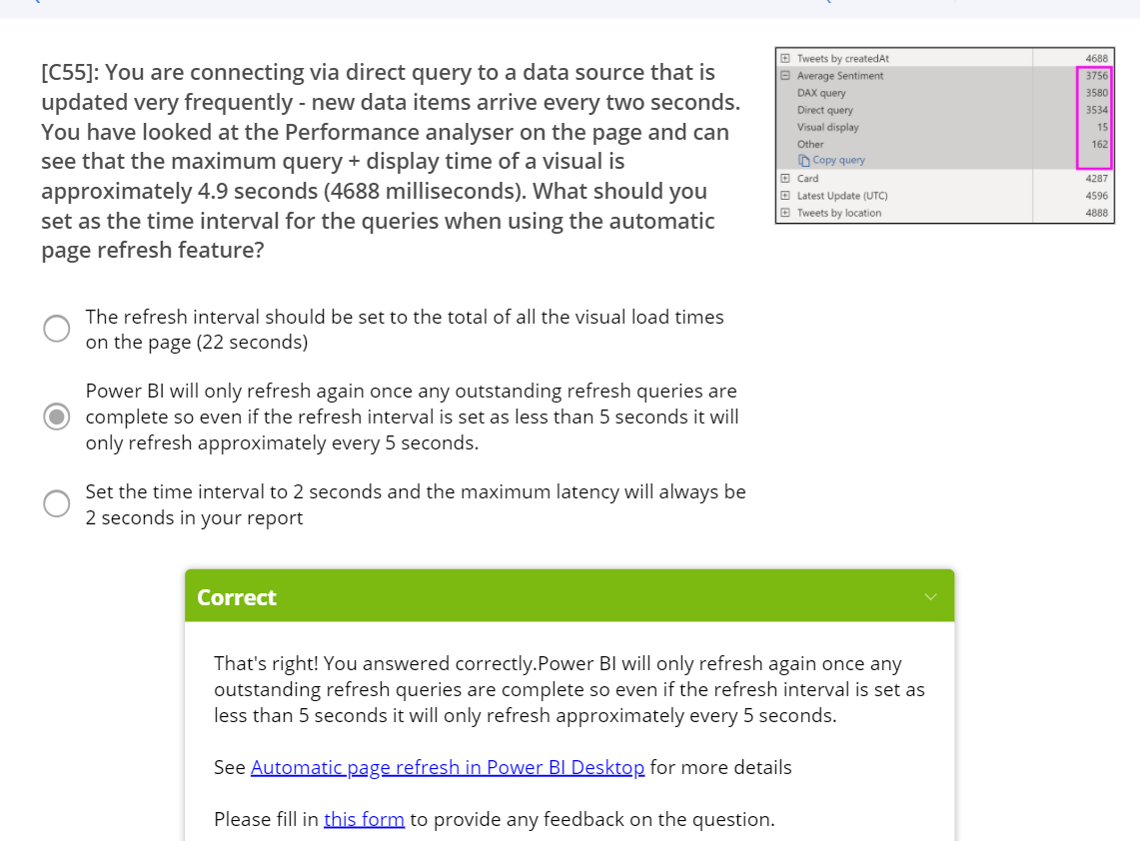

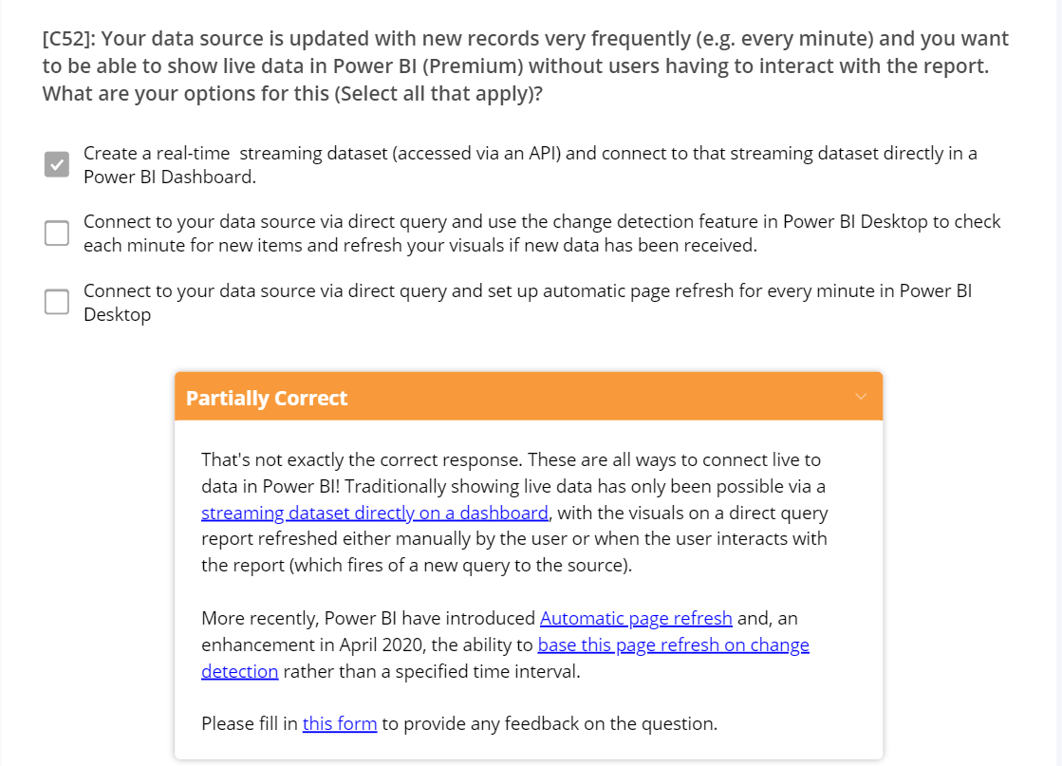

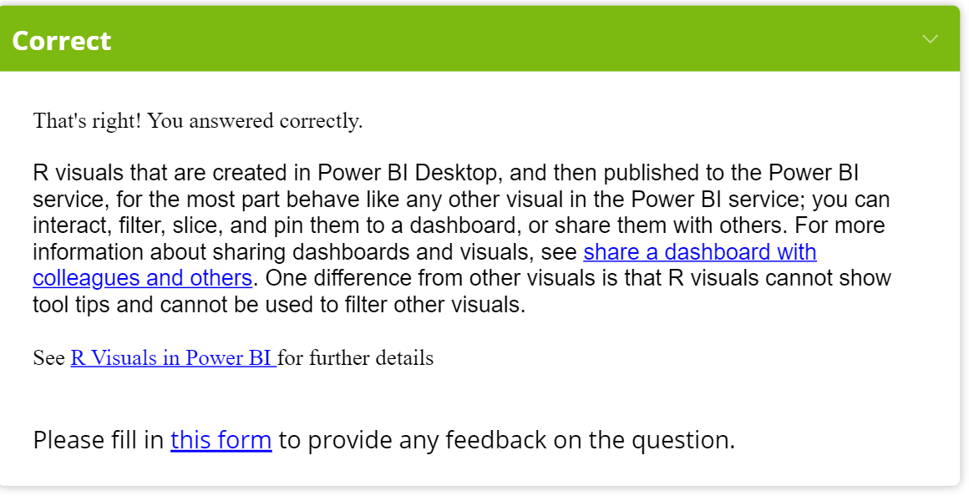

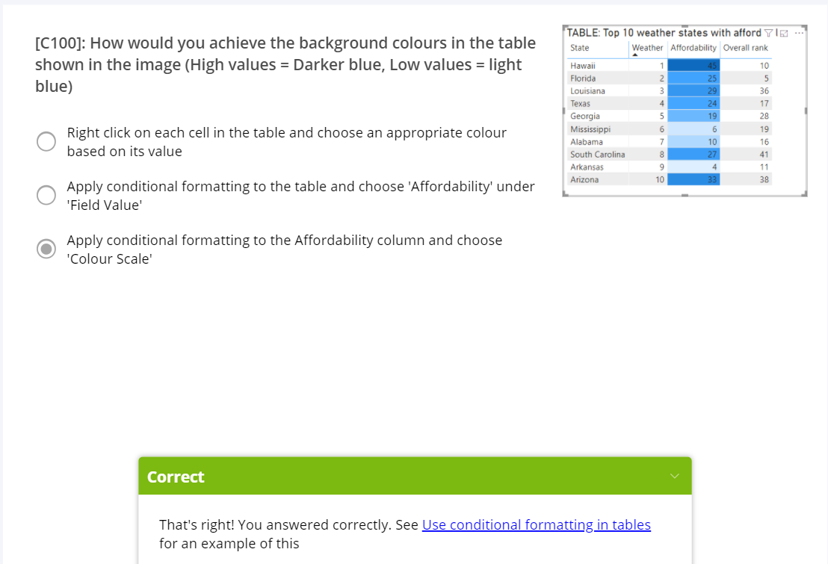

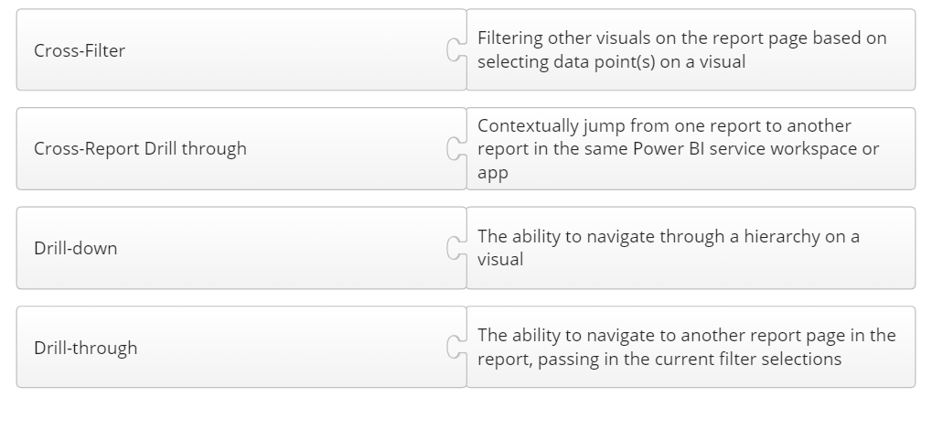

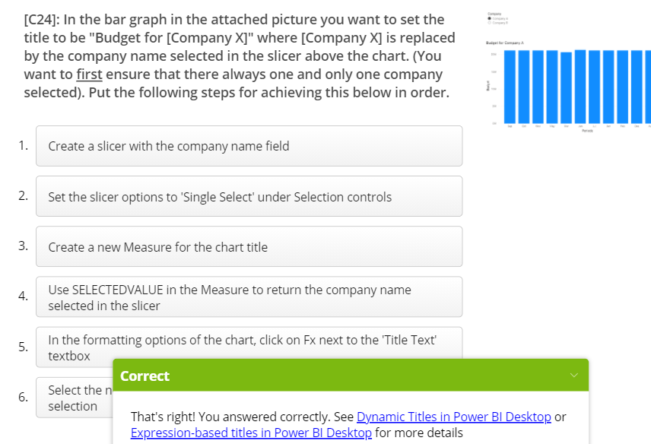

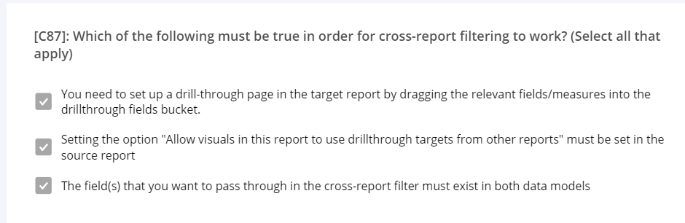

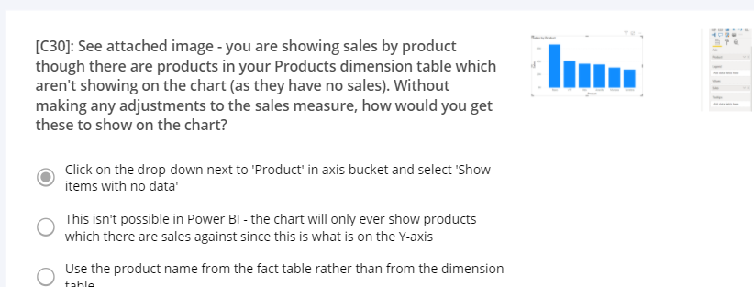

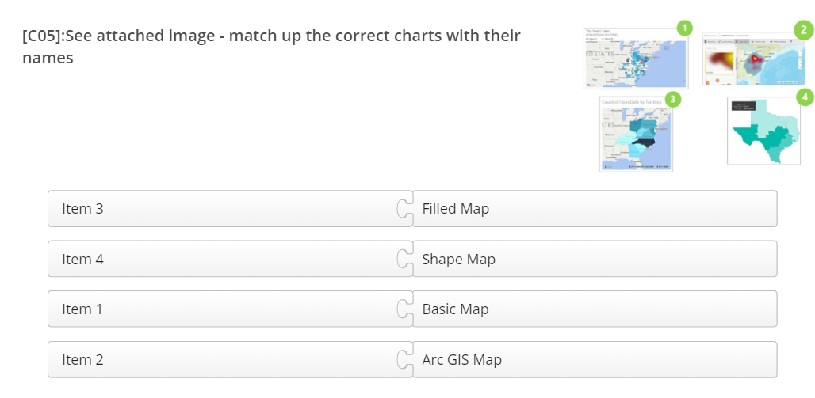

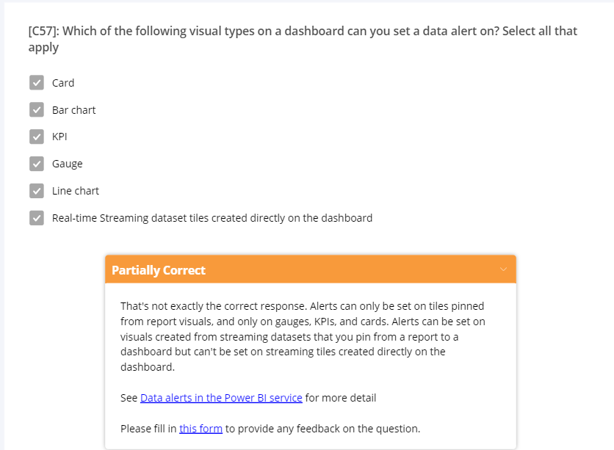

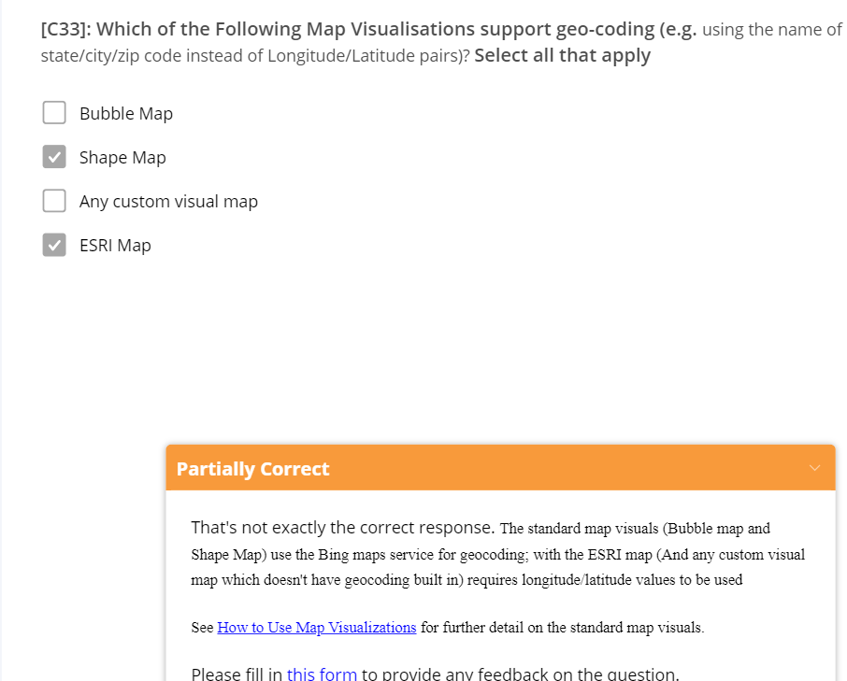

ToolTip

<https://www.youtube.com/watch?v=URTA7JZsAtw>

<https://www.youtube.com/watch?v=z1Z1axRSMzM>

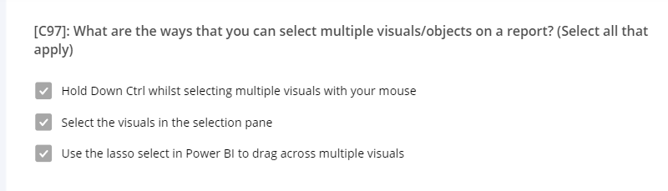

**R and Python**

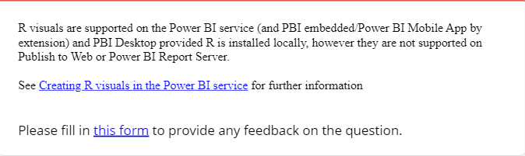

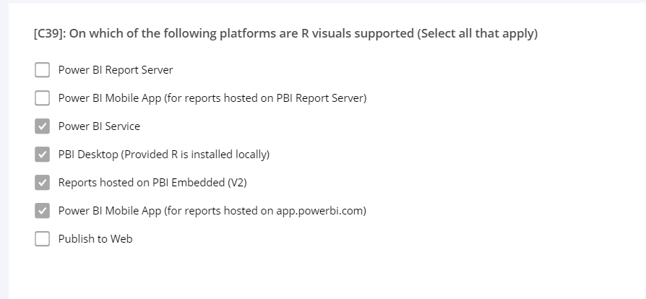

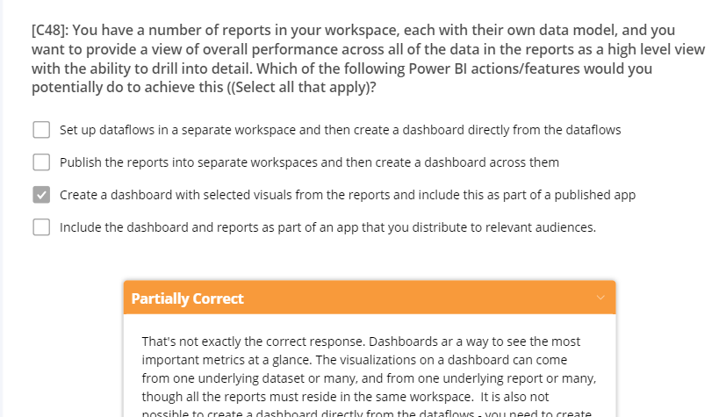

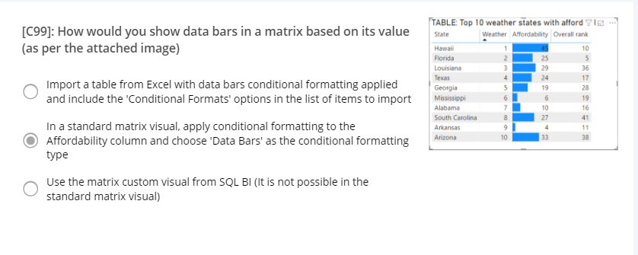

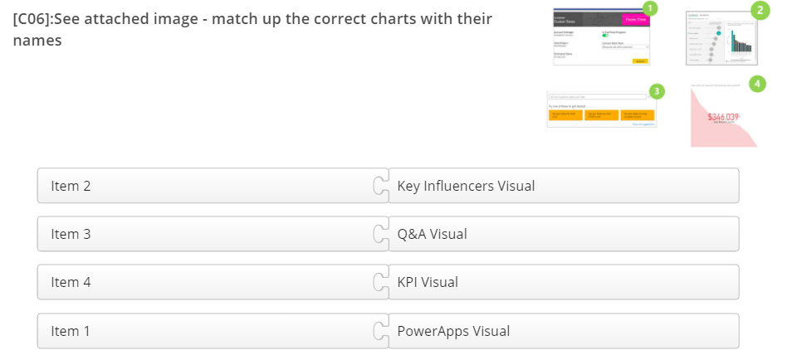

**CUSTOM VISUALS**

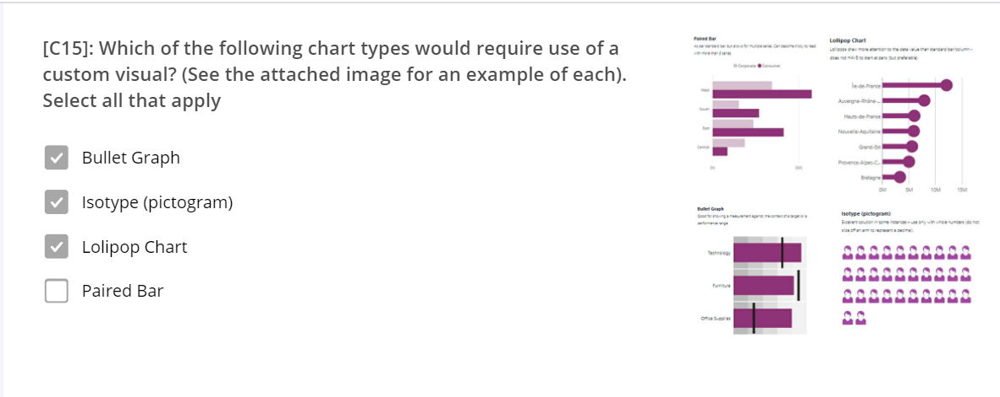

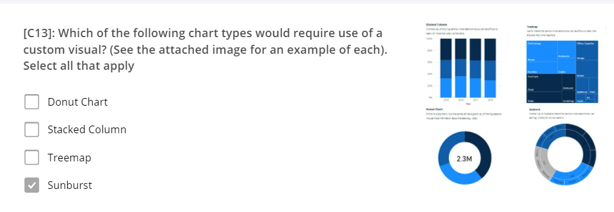

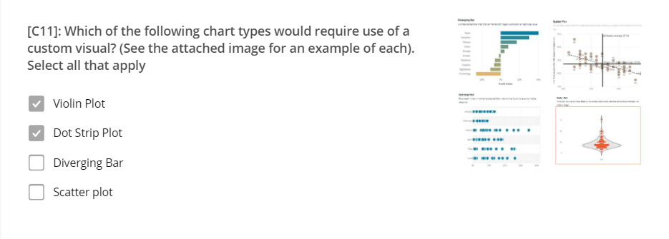

**ADMIN portal**

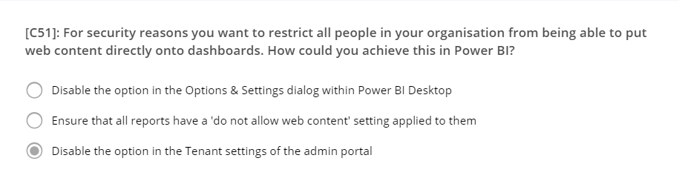

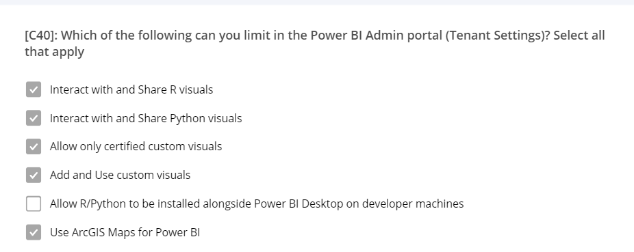

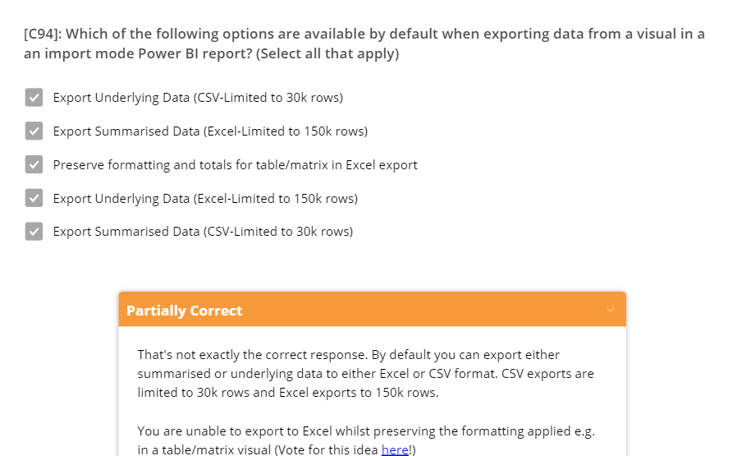

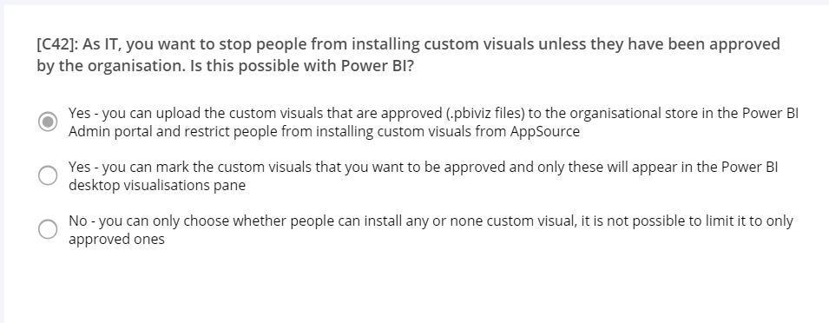

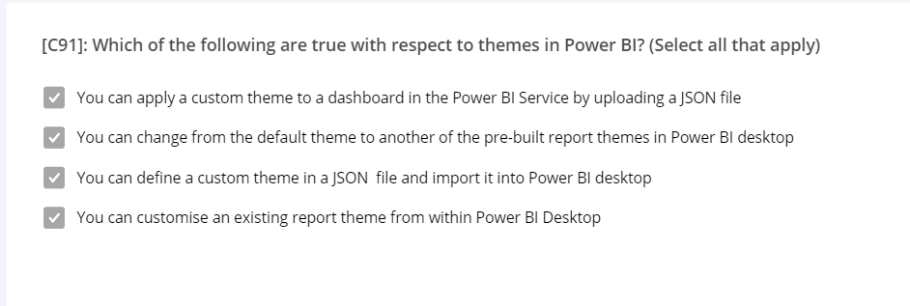

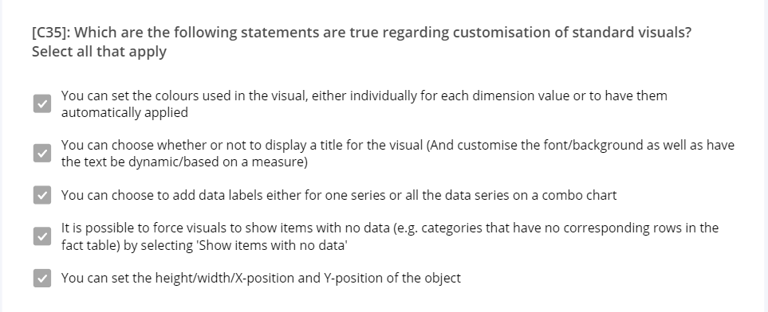

**YOUTUBE VIDEOS**

APP Workspace versus My Workspace

<https://www.youtube.com/watch?v=1fS8MvcaBGE>

COLLABORATION

https://www.youtube.com/watch?v=pij4gkznI2g

APP NAVIGATION

<https://www.youtube.com/watch?v=LOAAVP0NhcQ>

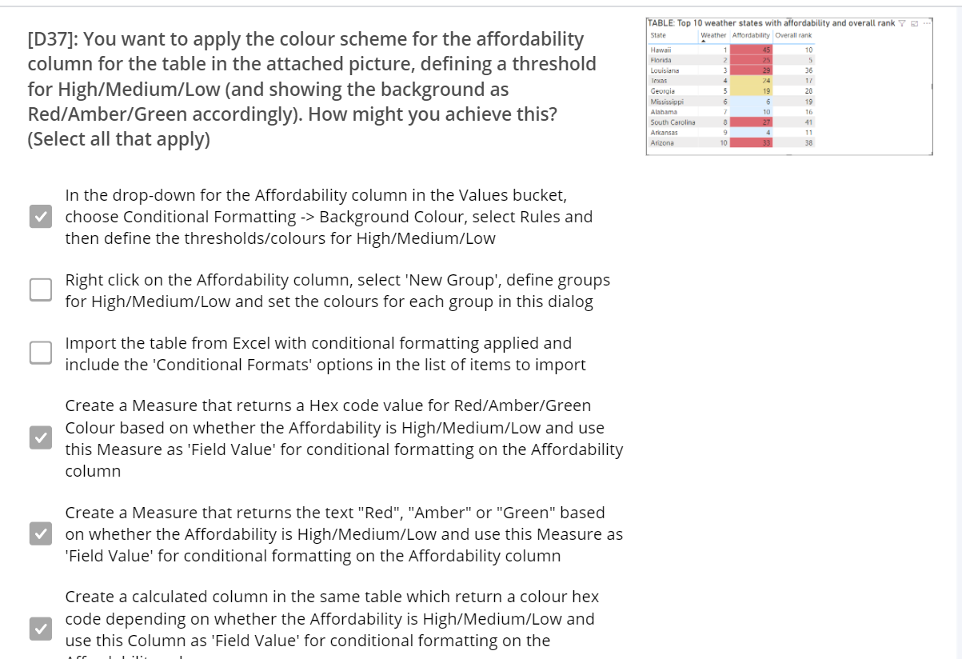

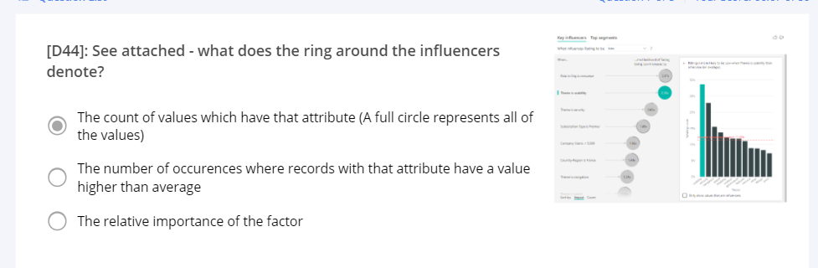

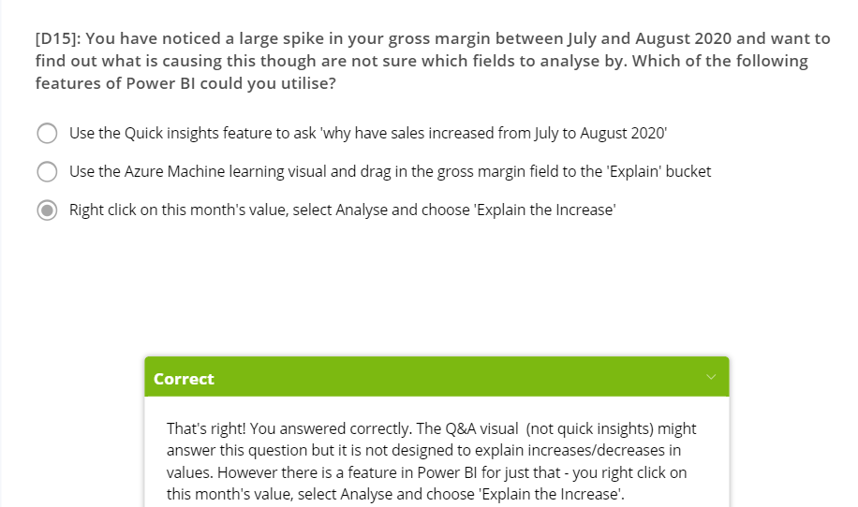

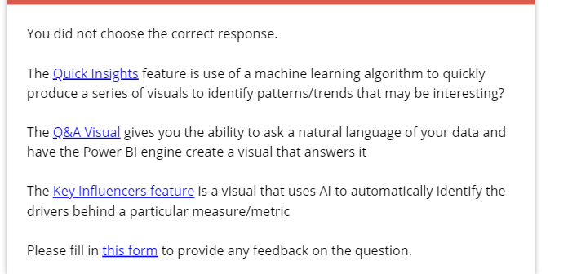

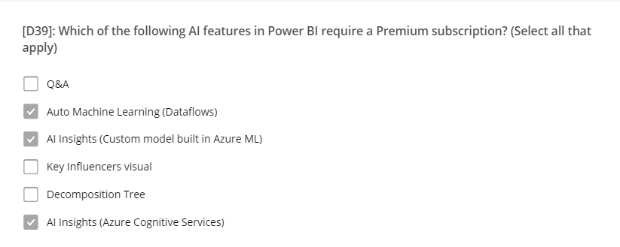

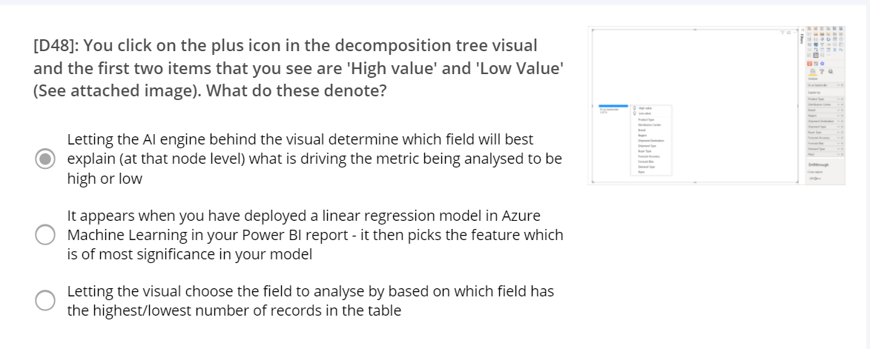

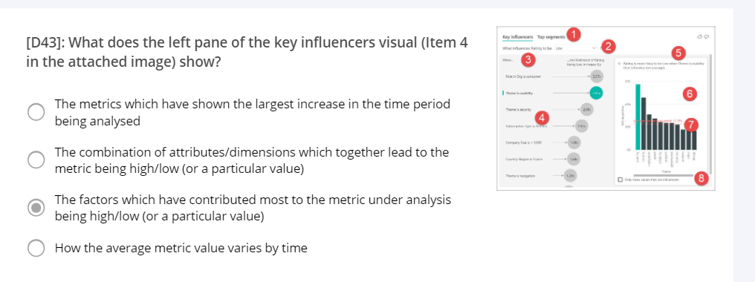

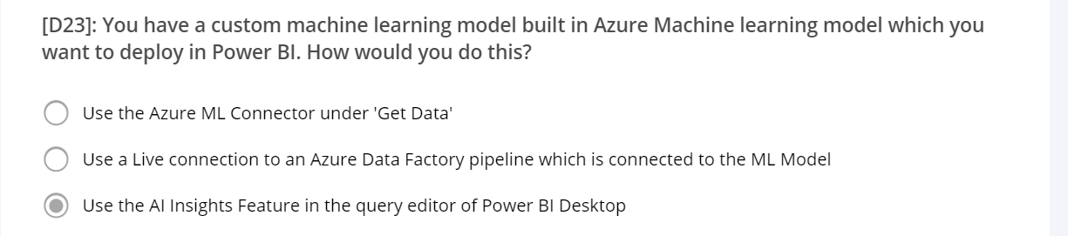

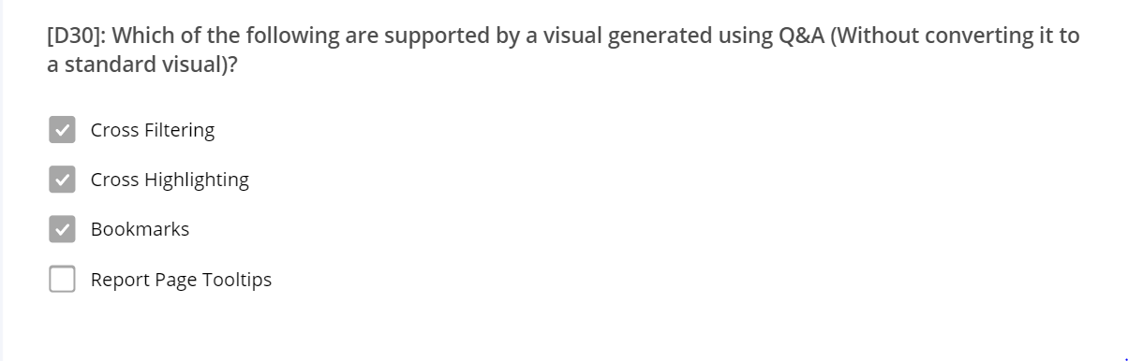

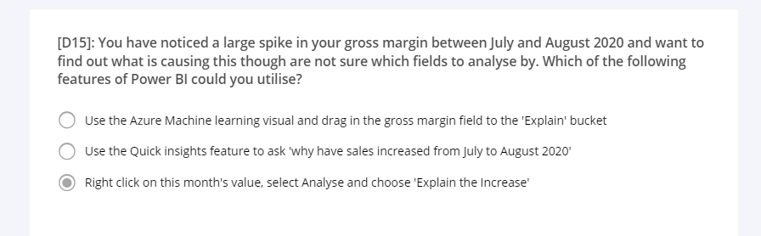

**You can slice by a Calculated Column. You cannot slice by a measure**

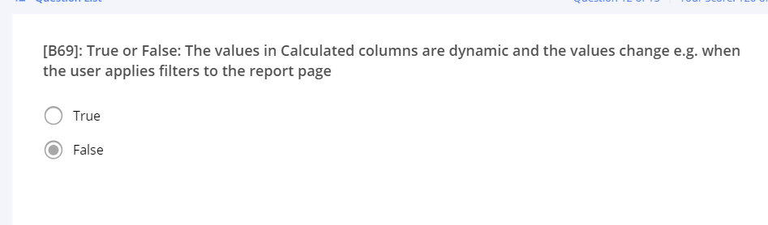

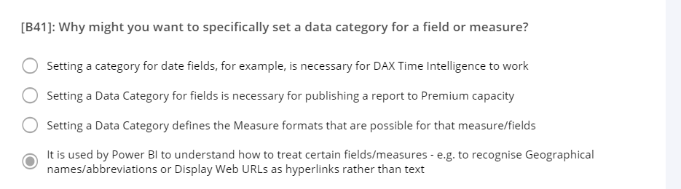

**ROW CONTEXT VERSUS FILTER CONTEXT**

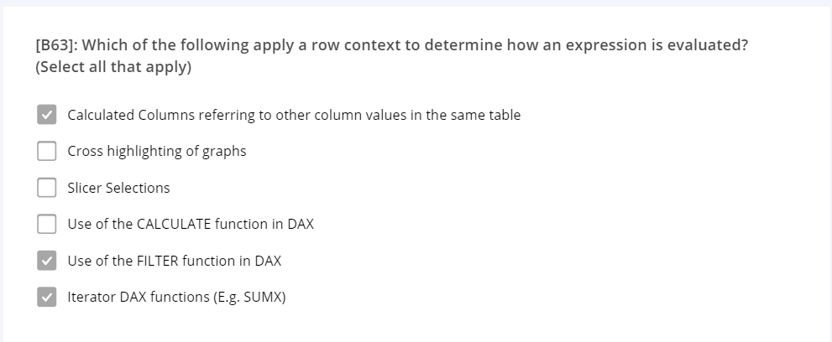

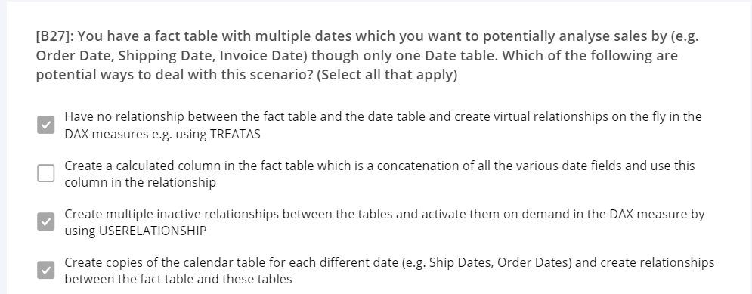

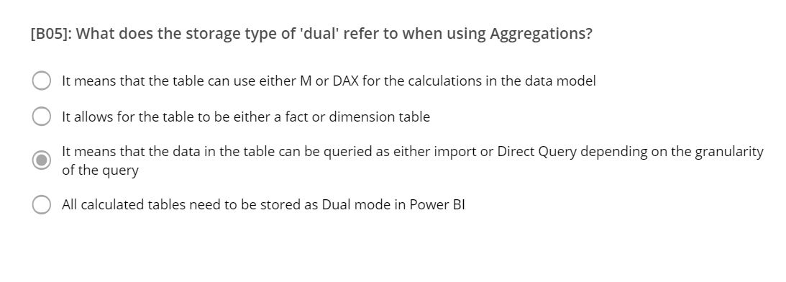

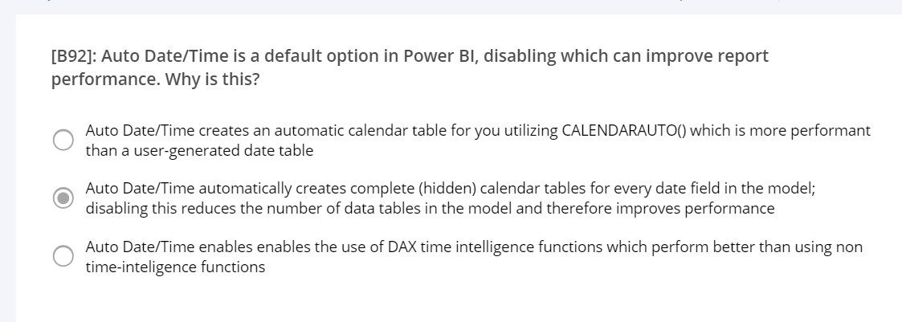

**Many to Many Relationships**

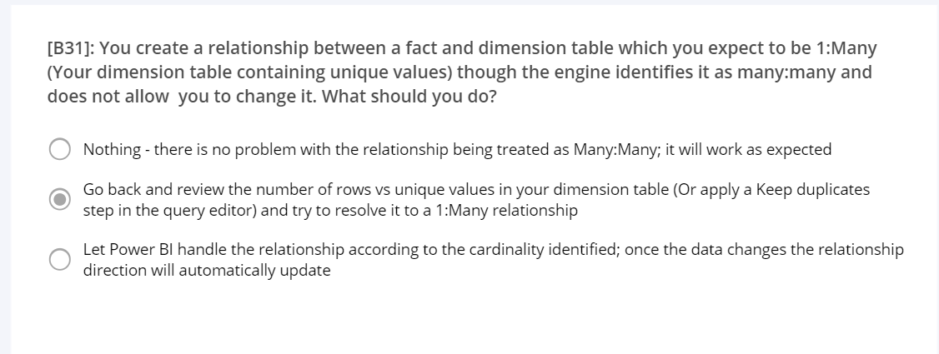

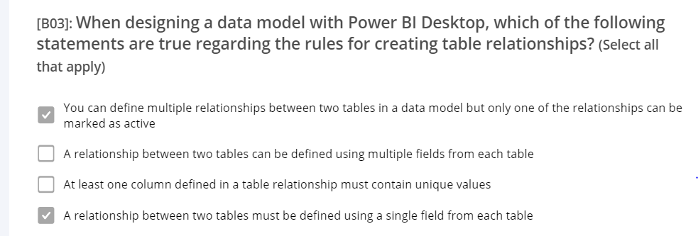

**Apps**

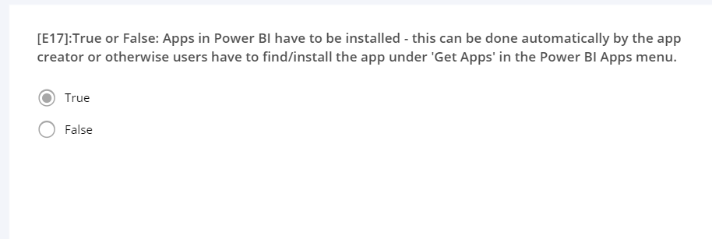

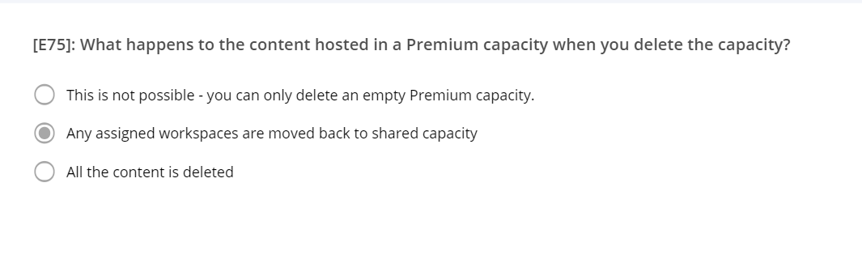

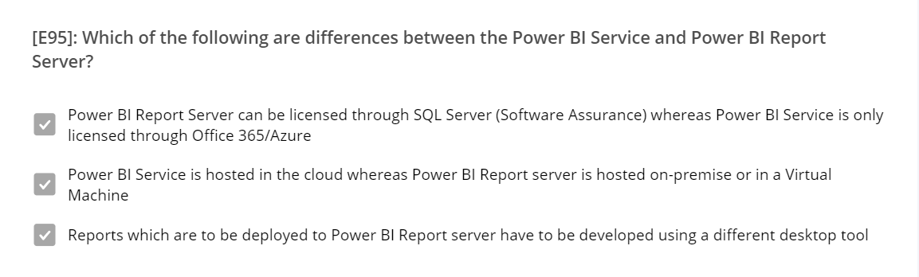

**Play Axis**

[**https://www.youtube.com/watch?v=2G_fOhbvQe8**](https://www.youtube.com/watch?v=2G_fOhbvQe8)

**Sync Slicers in View**

[**https://www.youtube.com/watch?v=BTjsPRPfBsA**](https://www.youtube.com/watch?v=BTjsPRPfBsA)

**Promote and Certify Datasets**

[**https://docs.microsoft.com/en-us/power-bi/connect-data/service-datasets-certify**](https://docs.microsoft.com/en-us/power-bi/connect-data/service-datasets-certify)

Sensitivity labels can be applied on datasets, reports, dashboards, and dataflows. When data is exported from Power BI to Excel, PowerPoint or PDF files, Power BI automatically applies a sensitivity label on the exported file and protects it according to the label’s file encryption settings. This way your sensitive data remains protected no matter where it is.

**Sensitivity label**

**https://www.youtube.com/watch?v=52hkwxepdjI**

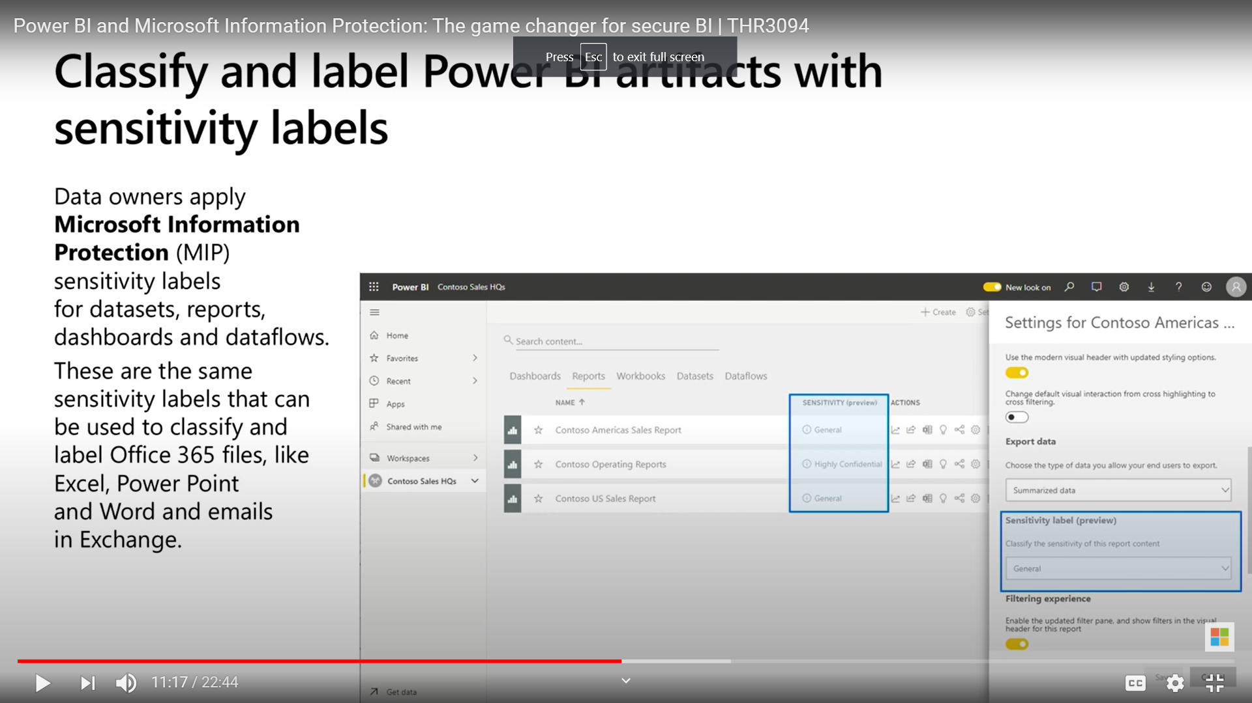

**Quick Insights**

**https://docs.microsoft.com/en-us/power-bi/create-reports/service-insights**

Insights doesn't work with DirectQuery; it only works with data uploaded to Power BI.

Refresh DataSet

[**https://www.youtube.com/watch?v=ClmZ-8p6x9g**](https://www.youtube.com/watch?v=ClmZ-8p6x9g)

**Desktop needs to be refreshed 🡪 Shared Sharepoint or OneDrive 🡪 Power BI Service Every hours (Without Gateway) Manual refresh No Gateway (no pro licence?)**

**Premium Capacity – Evry Half hour**

**Non Premium 8 times in a day**

**On Demand**

**Power Shell Call refresh API**

**Microsoft Flow:  
Trigger – when item is updated**

**Automatic Page refresh in Power BI Desktop**

[**https://docs.microsoft.com/en-us/power-bi/create-reports/desktop-automatic-page-refresh**](https://docs.microsoft.com/en-us/power-bi/create-reports/desktop-automatic-page-refresh)

Automatic page refresh in Power BI enables your active report page to query for new data, at a predefined cadence, for [DirectQuery sources](https://docs.microsoft.com/en-us/power-bi/connect-data/desktop-directquery-about).

## Refresh types

When using automatic page refresh, there are two refresh types available: fixed interval and change detection.

**https://www.youtube.com/watch?v=3irCvEe7IdI**

**https://www.youtube.com/watch?v=3irCvEe7IdI**

### Fixed interval setup

When selecting **Auto page refresh** as the refresh type, you need to provide the desired refresh interval. The default value is 30 minutes. (The minimum refresh interval is one second.) Your report will begin refreshing at the interval you set.

o configure automatic page refresh for reports in the Power BI service, the steps are similar to Power BI Desktop. When configured in the Power BI service, automatic page refresh also supports [embedded Power BI](https://docs.microsoft.com/en-us/power-bi/developer/embedded/embedding) content. This image shows the **Page refresh** configuration for the Power BI service:

## Automatic page refresh in the Power BI service

You can also set automatic page refresh for reports that have been published to the Power BI service as long as the data source is [DirectQuery](https://docs.microsoft.com/en-us/power-bi/connect-data/desktop-directquery-about).

**Shared workspaces**. For regular workspaces (workspaces that aren't part of a Premium capacity), automatic page refresh has a minimum interval of 30 minutes (the lowest interval allowed). Change detection refresh type is not available in shared capacities.

| **Storage mode** | **Dedicated capacity** | **Shared capacity** |
| --- | --- | --- |
| DirectQuery | **FI supported**: Yes **CD supported**: Yes **Minimum**: 1 second **Admin override**: Yes | **FI supported**: Yes **CD supported**: No **Minimum**: 30 minutes **Admin override**: No |
| |  |  |  | | --- | --- | --- | | Mixed mode (DirectQuery + other data sources) | **FI supported**: Yes **CD supported**: Yes **Minimum**: 1 second **Admin override**: Yes | **FI supported**: Yes **CD supported**: No **Minimum**: 30 minutes **Admin override**: No | |  |  |

Here are some details for the two workspace scenarios:

**Shared workspaces**. For regular workspaces (workspaces that aren't part of a Premium capacity), automatic page refresh has a minimum interval of 30 minutes (the lowest interval allowed). Change detection refresh type is not available in shared capacities.

**Premium workspaces**. The availability of automatic page refresh in Premium workspaces (both for fixed interval and change detection) depends on the workload settings your Premium administrator has set up for the Power BI Premium capacity. There are two variables that might affect your ability to set up automatic page refresh:

* **Feature on/off**. If your capacity administrator has disabled the feature, you won't be able to set up any type of page refresh in your published report. Fixed interval and change detection can be turned on and off separately.
* **Minimum refresh interval**. When enabling automatic page refresh for fixed interval, your capacity administrator needs to set up a minimum refresh interval (default value is five minutes). If your interval is lower than the minimum, the Power BI service overrides your interval to respect the minimum interval set by your capacity administrator.
* **Minimum execution interval**. When enabling change detection, your capacity administrator needs to set up a minimum execution interval (default value is five seconds). If your interval is lower than the minimum, the Power BI service overrides your interval to respect the minimum interval set by your capacity administrator

# Troubleshoot data by viewing its lineage

* 6 minutes

The **Lineage** view feature in Power BI allows you to quickly refresh datasets and see the relationships between the artifacts in a workspace and their external dependencies.

Consequently, you want the ability to determine which datasets need to be refreshed because you've been receiving reports of stale data.

The **Lineage** view feature in Power BI is crucial because it:

* Simplifies the troubleshooting process because you can see the path that the data takes from source to destination and determine pain points and bottlenecks.
* Allows you to manage your workspaces and observe the impact of a single change in one dataset to reports and dashboards.
* Saves time by simplifying your task of identifying reports and dashboards that haven't been refreshed.

You can also view the impact of this dataset across workspaces. By selecting the overlapping window icon on the lower-right corner of a dataset card, you can determine the impact analysis of the dataset.

## Set up data classification on dashboards

Data classification helps the dashboard owner raise security awareness to viewers of a dashboard so that they know what level of security should be considered when viewing or sharing a dashboard. Data classification does not enforce policies because data protection does.

# Introduction to paginated reports

* 2 minutes

Paginated reports allow report developers to create Power BI artifacts that have tightly controlled rendering requirements. Paginated reports are ideal for creating sales invoices, receipts, purchase orders, and tabular data. This module will teach you how to create reports, add parameters, and work with tables and charts in paginated reports.

Paginated reports give a pixel-perfect view of the data. Pixel perfect means that you have total control of how the report renders. If you want a footer on every sales receipt that you create, a paginated report is the appropriate solution. If you want a certain customer's name to always appear in green font on a report, you can do that in a paginated report.

You can use paginated reports for operational reports with tables of details and optional headers and footers.

t is to get data from a data source. Though this process might seem similar to getting data in Power BI, it is different. Power BI paginated reports do not use Power Query when connecting to data sources.

Getting data in a Power BI paginated report does not involve data cleaning steps. In fact, data is not stored in a Power BI paginated report dataset. When data is refreshed on the report, it is retrieved in an unaltered form from the data source, according to the query that was used to retrieve it.

### Create and configure a dataset

A data source is the connection information to a particular resource, like SQL Server. A dataset is the saved information of the query against the data source, not the data. The data always resides in its original location.

Another aspect of creating a report is to add a parameter. Parameters can be used for different reasons, for example, when you want the user to enter information that displays on a visual on the report. The most popular reason to add a parameter is to affect which data is retrieved from the data source.

The following example shows conditional formatting being used in two visuals, **Table** and **Matrix**, where it is possible to set different conditions on a column. You can apply conditional formatting to any text or data field, but the formatting needs to be based on a field that has numeric, color name or hex code, or web URL values.

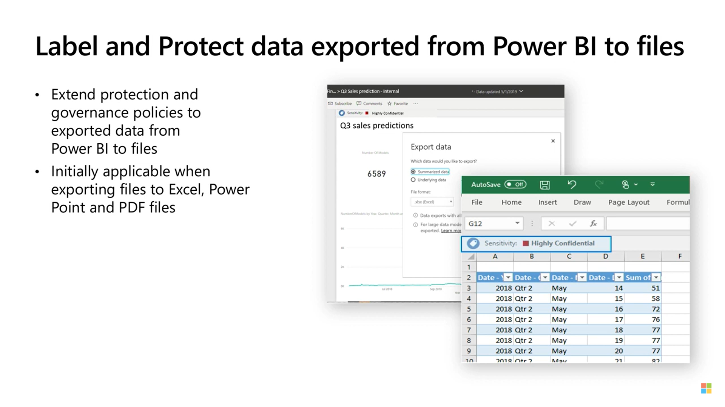

**Aggregation and Group By**

[**https://www.youtube.com/watch?v=EhGF372t0sU**](https://www.youtube.com/watch?v=EhGF372t0sU)

**Licence Pro**

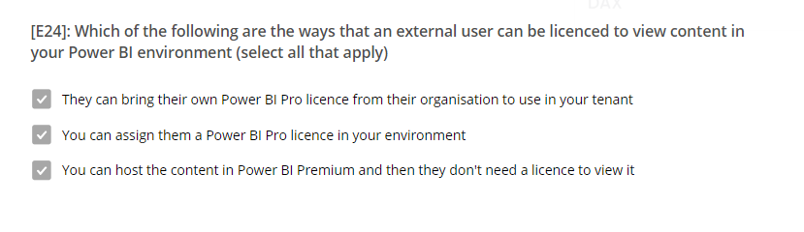

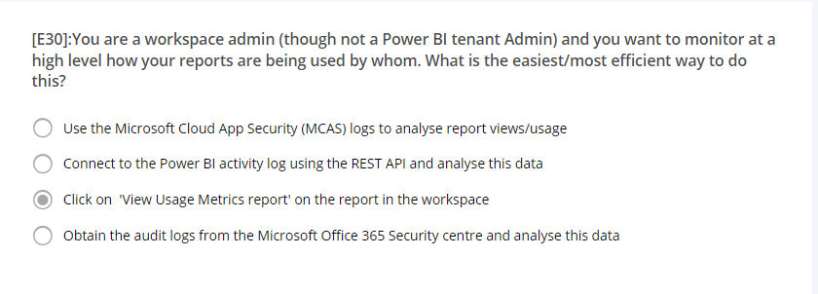

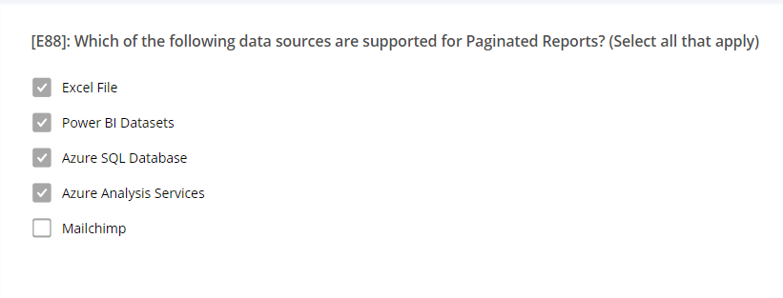

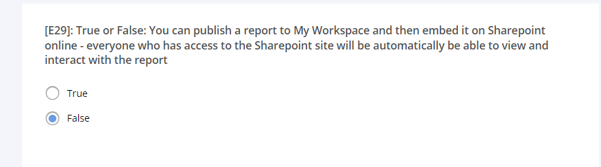

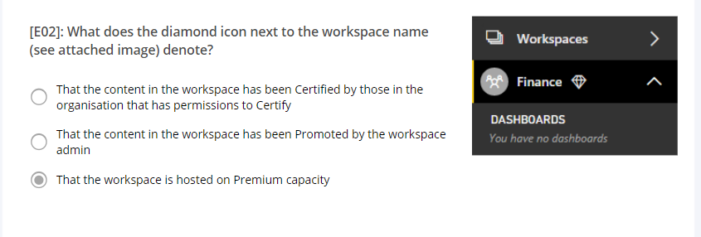

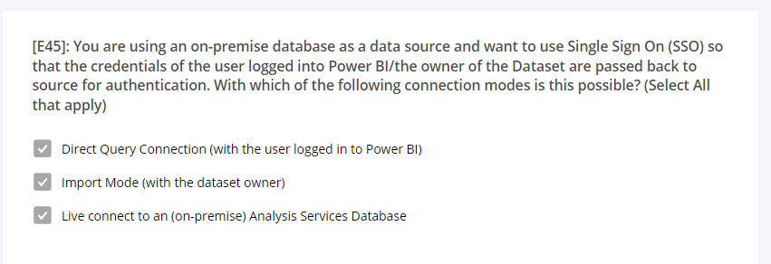

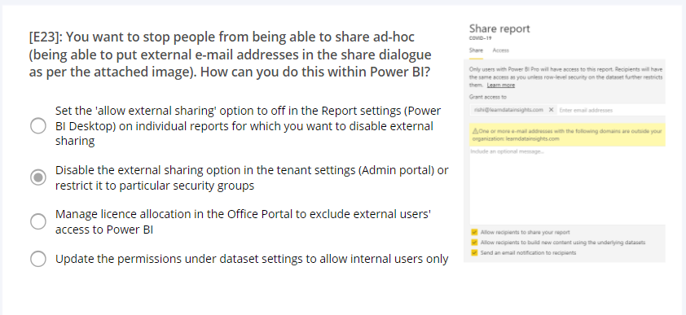

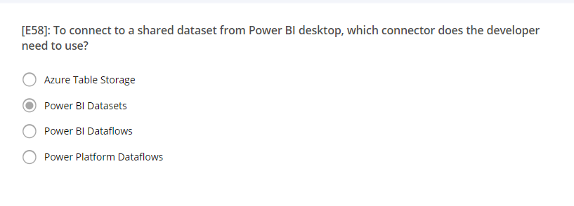

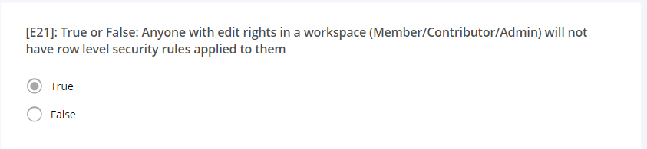

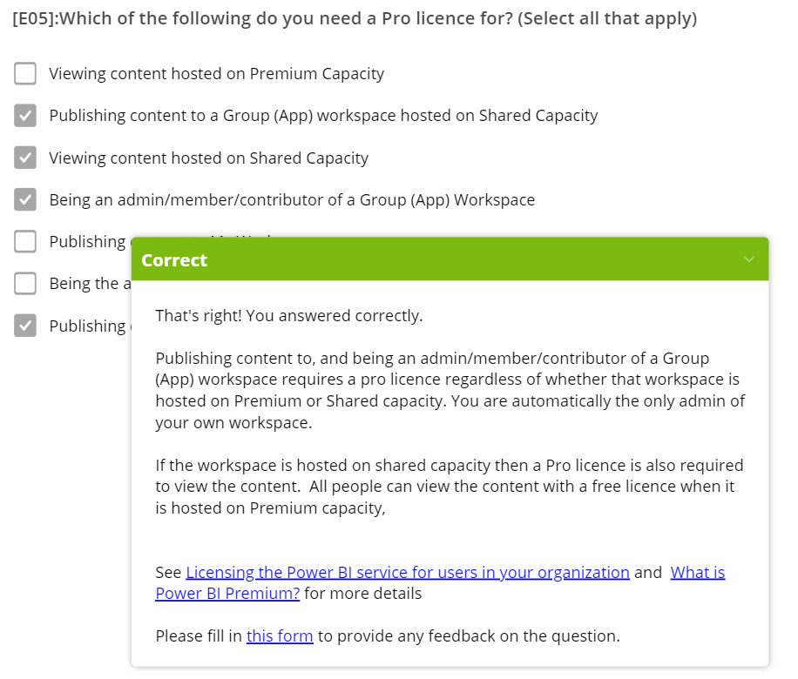

To apply clustering to your scatter chart, select **More options** (**...**) in the upper-right corner of the visual and then select **Automatically find clusters**.

o use the **Analyze** feature, right-click a data point on the visual and then hover over the **Analyze** option to display two further options: **Explain the increase** and **Find where the distribution is different**. The options that are available will depend on the data point that you selected.

The **AI Insights** feature allows you to connect to a collection of pretrained machine learning models that you can apply to your data to enhance your data preparation efforts.

 good guideline to remember is that if you can translate a transformation into a **Select** SQL statement, which includes operators and clauses such as GROUP BY, SORT BY, WHERE, UNION ALL, and JOIN, you can use query folding.

**========================================================================================================================================================**

**OneDrive for Business** - You can pull data from OneDrive for Business into Power BI. This method is effective in keeping an Excel file and your dataset, reports, and dashboards in Power BI synchronized. Power BI connects regularly to your file on OneDrive. If any changes are found, your dataset, reports, and dashboards are automatically updated in Power BI.

Select **Data source settings** in Power Query. In the **Data source settings** window, select your file and then select **Change Source**. Update the **File path** or use the **Browse** option to locate your file, select **OK**, and then select **Close**.

After you create a data source connection and load data into Power BI Desktop, you can return and change your connection settings at any time. This action is often required due to a security policy within the organization, for example, when the password needs to be updated every 90 days. You can change the data source, edit permissions or clear permissions.

### Import a JSON file

JSON type records must be extracted and normalized before you can report on them, so you need to transform the data before loading it into Power BI Desktop.

**Direct mode**

Using this model ensures that you are always viewing the most up-to-date data, and that all security requirements are satisfied. Additionally, this mode is suited for when you have large datasets to pull data from. Instead of slowing down performance by having to load large amounts of data into Power BI, you can use DirectQuery to create a connection to the source, solving data latency issues as well.

Getting data from Azure Analysis Services cubes is similar to getting data from SQL Server, in that you can:

* Authenticate to the server.
* Pick the cube you want to use.
* Select which tables you need.

Notable differences between Azure Analysis Services cubes and SQL Server are:

* Analysis Services cubes have calculations already in the cube, which will be discussed in more detail later.
* If you don’t need an entire table, you can query the data directly. Instead of using Transact-SQL (T-SQL) to query the data, like you would in SQL Server, you can use multi-dimensional expressions (MDX) or data analysis expressions (DAX).

**Connect live** is a new option in Azure Analysis Services. Azure Analysis Services uses the tabular model and DAX to build calculations, similar to Power BI. These models are compatible with one another. Using the Connect live option helps you keep the data and DAX calculations in their original location, without having to import them all into Power BI. Azure Analysis Services can have a fast refresh schedule , which means that when data is refreshed in the service, Power BI reports will immediately be updated, without the need to initiate a Power BI refresh schedule. This process can improve the timeliness of the data in your report.

The benefits to query folding include:

* **More efficiency in data refreshes and incremental refreshes.** When you import data tables by using query folding, Power BI is better able to allocate resources and refresh the data faster because Power BI does not have to run through each transformation locally.
* **Automatic compatibility with DirectQuery and Dual storage modes.** All DirectQuery and Dual storage mode data sources must have the back-end server processing abilities to create a direct connection, which means that query folding is an automatic capability that you can use. If all transformations can be reduced to a single **Select** statement, then query folding can occur.

Other ways to optimize query performance in Power BI include:

* **Process as much data as possible in the original data source.** Power Query and Power Query Editor allow you to process the data; however, the processing power that is required to complete this task might lower performance in other areas of your reports. Generally, a good practice is to process, as much as possible, in the native data source.
* **Use native SQL queries.** When using DirectQuery for SQL databases, such as the case for our scenario, make sure that you are not pulling data from stored procedures or common table expressions (CTEs).
* **Separate date and time, if bound together.** If any of your tables have columns that combine date and time, make sure that you separate them into distinct columns before importing them into Power BI. This approach will increase compression abilities.

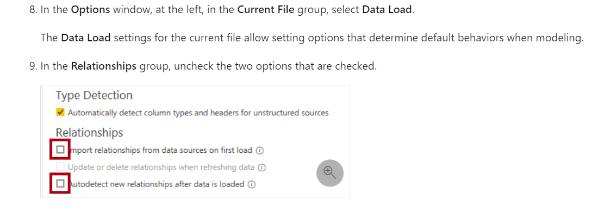

Unpivot/melt

You can rename the **Attribute** column to **Year** and the **Value** column to **SalesAmount**.

Unpivoting streamlines the process of creating DAX measures on the data later. By completing this process, you have now created a simpler way of slicing the data with the **Year** and **Month** columns.

Pivoting a column makes its values become individual column headers

The values within then need to be aggregated

## Remove duplicates

You can also remove duplicates from columns to only keep unique names in a selected column by using the **Remove Duplicates** feature in Power Query.

Privacy levels can be configured for data source to determine whether data can be shared between sources. Setting each data source as **Organizational** allows them to share data, if necessary. Private data sources can never be shared with other data sources. It doesn't mean that Private data cannot be shared; it means that the Power Query engine cannot share data between the sources.\

To apply the **AI Insights** feature to your data, open Power Query Editor and select the **Add Column** tab. Three **AI Insights** options will be available for you to choose from: **Text Analytics**, **Vision**, and **Azure Machine Learning**.

On the **Add column** tab, the most relevant **AI Insights** option for this example is **Text Analytics**. This option includes Azure Cognitive Services models, such as Sentiment Analysis, Key Phrase Extraction, and Language Detection, that derive meaning or specific pieces of language from text data. You can use either the Sentiment Analysis or Key Phrase Extraction option to determine the customer sentiments in the Help tickets and visually show the results in Power BI.

In this example, you've built several visuals for the Customer Service team, and now you want to understand the factors that most influence your metrics. Specifically, you want to figure out what factors are affecting the total number of logged tickets. One factor might be the client type and another might be location, but you're uncertain. The **Key influencers** visual will find that information for you.

The **Decomposition Tree** visual automatically aggregates your data and lets you drill down into your dimensions so that you can view your data across multiple dimensions. Because **Decomposition Tree** is an AI visual, you can use it for improvised exploration and conducting root cause analysis.

AI splits work by considering all available fields and determining which one to drill into to get the highest/lowest value of the measure that is being analyzed. You can use the results of these splits to find out where you should look next in the data. The following image illustrates the result of selecting the **High value** AI split.

The chart can be animated when a field is added to the **Play Axis** well.

To add a forecast, beneath the **Visualizations** pane, select the **Analytics** pane.

[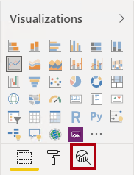](https://docs.microsoft.com/en-us/learn/modules/ai-visuals-power-bi/media/lab-16-ssm.png#lightbox)

Q&A what are the numbers

Decomposition tree and Key Influencers- what causes the numbers to increase or decrease

AI splits

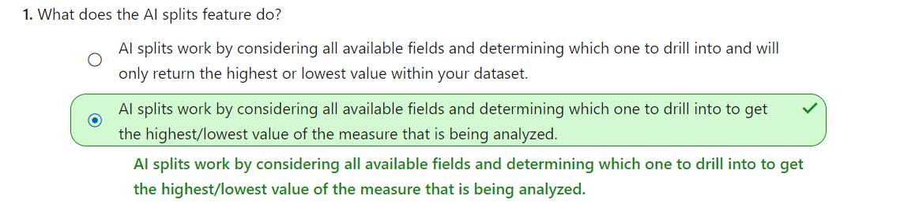

. Next, you added the **Key influencers** visual to your report so that users could understand the factors that affect a specific metric. Finally, you added a **Decomposition Tree** visual to your reports so that users could view your data across multiple dimensions and conduct root cause analysis.

By marking your table as a date table, Power BI performs validations to ensure that the data contains zero null values, is unique, and contains continuous date values over a period. You can also choose specific columns in your table to mark as the date, which can be useful when you have many columns within your table. Right-click the table, select **Mark as date table**, and then select **Date table settings.** The following window will appear, where you can choose which column should be marked as **Date**.

Selecting **Mark as date table** will remove autogenerated hierarchies from the **Date** field in the table that you marked as a date table. For other date fields, the auto hierarchy will still be present until you establish a relationship between that field and the date table or until you turn off the **Auto Date/Time** feature.

## Hierarchies

When you are building visuals, Power BI automatically enters values of the date type as a hierarchy (if the table has not been marked as a date table).

Set the **Stepped Layout** property to **Off**.

[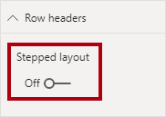](https://docs.microsoft.com/en-us/learn/modules/create-measures-dax-power-bi/media/lab-8-5-ssm.png#lightbox)

The CALCULATE() function is a powerful function used to manipulate the filter context. The first argument takes an expression or a measure (a measure is just a named expression). Subsequent arguments allow modifying the filter context.

The REMOVEFILTERS() function removes active filters. It can take either no arguments, or a table, a column, or multiple columns as its argument.

Sales % Country =

IF(

ISINSCOPE(Region[Region]),

DIVIDE(

SUM(Sales[Sales]),

CALCULATE(

SUM(Sales[Sales]),

REMOVEFILTERS(Region[Region]

)

)

)

Embedded within the IF() function, the ISINSCOPE() function is used to test whether the region column is the level in a hierarchy of levels. When true, the DIVIDE() function is evaluated. The absence of a false part means that blank is returned when the region column is not in scope.

Sales YoY Growth =

VAR SalesPriorYear =

CALCULATE(

SUM(Sales[Sales]),

PARALLELPERIOD(

'Date'[Date],

-12,

MONTH

)

)

RETURN

DIVIDE(

(SUM(Sales[Sales]) - SalesPriorYear),

SalesPriorYear

)

## Flatten parent-child hierarchy

The process of viewing multiple child levels based on a top-level parent is known as flattening the hierarchy. In this process, you are creating multiple columns in a table to show the hierarchical path of the parent to the child in the same record. You will use PATH(), a simple DAX function that returns a text version of the managerial path for each employee, and PATHITEM() to separate this path into each level of managerial hierarchy.

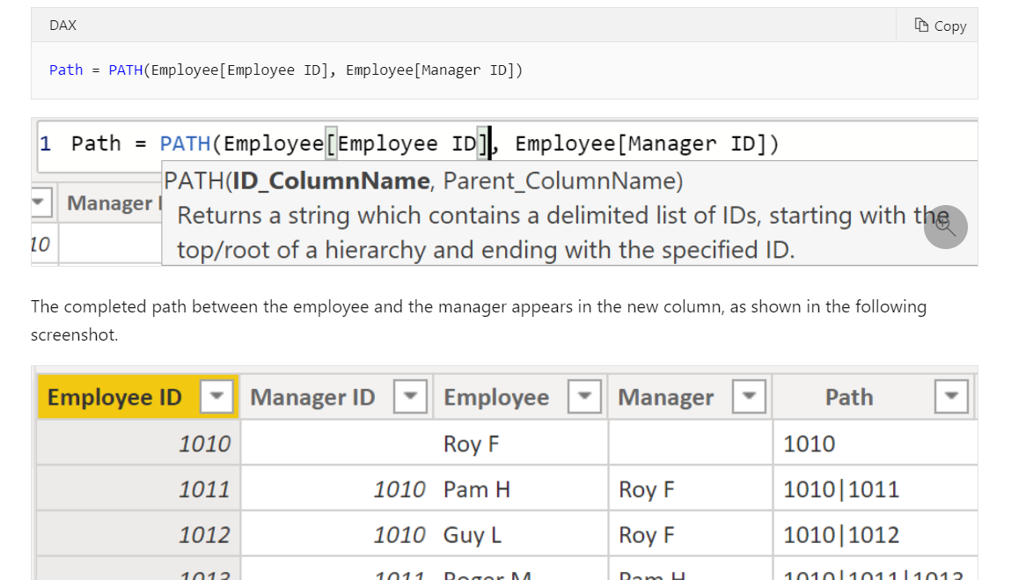

## Role-playing dimensions

Role-playing dimensions have multiple valid relationships with fact tables, meaning that the same dimension can be used to filter multiple columns or tables of data. As a result, you can filter data differently depending on what information you need to retrieve. This topic is complex, so it is only introduced in this section. Working with role-playing dimensions requires complex DAX functions that will be discussed in later sections.

How can you change the granularity of the data to make the dataset more usable?

In this scenario, you might want to import the data by using a daily average for each truck. That approach would reduce the records in the database to one record for each truck for each day. If you decide that the approach was acceptable enough for tracking costs and errors, then you could use that data granularity. Alternatively, you could select the last recorded temperature, or you could only import records that are above or below a normal range of temperatures. Any of these methods will reduce the total records that you import, while still bringing in data that is comprehensive and valuable.

# Relationships

One-to-one (1:1) cardinality:

* Describes a relationship in which only one instance of a value is common between two tables.
* Requires unique values in both tables.
* Is not recommended because this relationship stores redundant information and suggests that the model is not designed correctly. It is better practice to combine the tables.

An example of a one-to-one relationship would be if you had products and product IDs in two different tables. Creating a one-to-one relationship is redundant and these two tables should be combined.

## Cardinality and cross-filter direction

For one-to-one relationships, the only option that is available is bi-directional cross-filtering. Data can be filtered on either side of this relationship and result in one distinct, unambiguous value

Categorize the following three columns:

* **Country-Region** as **Country/Region**
* **State-Province** as **State or Province**
* **City** as **City**
* In the **Properties** pane, in the **Description** box, enter: **Based on standard cost**
* *Descriptions can be applied to table, columns, hierarchies, or measures. In the****Fields****pane, description text is revealed in a tooltip when a report author hovers their cursor over the field.*

### Bulk update properties

In this task, you will update multiple columns in a single bulk update. You will use this approach to hide columns, and format column values.

1. While pressing the **Ctrl** key, select the following 13 columns (spanning multiple tables):
   * Product | ProductKey
2. In the **Properties** pane, slide the **Is Hidden** property to **On**.
3. *The columns were hidden because they are either used by relationships or calculation logi*
4. In the **Fields** pane, notice the following:
   * Columns, hierarchies, and their levels are fields, which can be used to configure report visuals
   * Only fields relevant to report authoring are visible
   * The **SalespersonRegion** table is not visible because all of its fields are hidden
   * Spatial fields in the **Region** and **Reseller** table are adorned with a spatial icon
   * Fields adorned with the sigma symbol (Ʃ) will summarize, by default
   * A tooltip appears when hovering the cursor over the **Sales | Cost** field

The DAX calculated column does not compress as well as the other methods. The other column types do get compressed, which makes the .pbix file smaller and the performance usually faster.

Generally, the earlier you can create a column, the better. It is not considered an optimum practice to use DAX for calculations if you can use a different mechanism.

Last Inventory Count =

CALCULATE (

SUM ( 'Warehouse'[Inventory Count] ),

LASTDATE ( 'Date'[Date] ))

**This approach will stop the SUM from crossing all dates.** Instead, you will only use the SUM function on the last date of the time period, thus effectively creating a semi-additive measure.

The CALENDARAUTO() function returns a single-column table consisting of date values. The “auto” behavior scans all data model date columns to determine the earliest and latest date values stored in the data model. It then creates one row for each date within this range, extending the range in either direction to ensure full years of data is stored.

This function can take a single optional argument which is the last month number of a year. When omitted, the value is 12, meaning that December is the last month of the year. In this case 6 is entered, meaning that June is the last month of the year.

Create a measure for summarization

In the **Values** well, open the context menu for the **Avg Price** field, and notice that it is not possible to change the aggregation technique.

[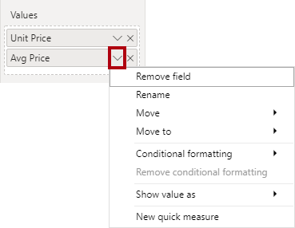](https://docs.microsoft.com/en-us/learn/modules/create-measures-dax-power-bi/media/lab-6-31-ssm.png#lightbox)

For the multi-selection of measures, configure the following requirements:

* Set the format to two decimal places
* Assign to a display folder named **Pricing**

Removing meaningless Total

Create the following measure on the **Targets** table:

DAXCopy

Target =

IF(

HASONEVALUE('Salesperson (Performance)'[Salesperson]),

SUM(Targets[TargetAmount])

)

The HASONEVALUE() function tests whether a single value in the **Salesperson** column is filtered. When true, the expression returns the sum of target amounts (for just that salesperson). When false, BLANK is returned.

Before you run **Performance analyzer**, to ensure you get the most accurate results in your analysis (test), make sure that you start with a clear visual cache and a clear data engine cache.

* **Visual cache** - When you load a visual, you can't clear this visual cache without closing Power BI Desktop and opening it again. To avoid any caching in play, you need to start your analysis with a clean visual cache.

To ensure that you have a clear visual cache, add a blank page to your Power BI Desktop (.pbix) file and then, with that page selected, save and close the file. Reopen the Power BI Desktop (.pbix) file that you want to analyze. It will open on the blank page.

* **Data engine cache** - When a query is run, the results are cached, so the results of your analysis will be misleading. You need to clear the data cache before rerunning the visual.

To clear the data cache, you can either restart Power BI Desktop or connect DAX Studio to the data model and then call Clear Cache.

* **DAX query** - The time it took for the visual to send the query, along with the time it took Analysis Services to return the results.
* **Visual display** - The time it took for the visual to render on the screen, including the time required to retrieve web images or geocoding.
* **Other** - The time it took the visual to prepare queries, wait for other visuals to complete, or perform other background processing tasks. If this category displays a long duration, the only real way to reduce this duration is to optimize DAX queries for other visuals, or reduce the number of visuals in the report.

# Use variables to improve performance and troubleshooting

* **Improved performance** - Variables can make measures more efficient because they remove the need for Power BI to evaluate the same expression multiple times. You can achieve the same results in a query in about half the original processing time.
* **Improved readability** - Variables have short, self-describing names and are used in place of an ambiguous, multi-worded expression. You might find it easier to read and understand the formulas when variables are used.
* **Simplified debugging** - You can use variables to debug a formula and test expressions, which can be helpful during troubleshooting.
* **Reduced complexity** - Variables do not require the use of EARLIER or EARLIEST DAX functions, which are difficult to understand. These functions were required before variables were introduced, and were written in complex expressions that introduced new filter contexts. Now that you can use variables instead of those functions, you can write fewer complex formulas

Cardinality is a term that is used to describe the uniqueness of the values in a column. Cardinality is also used in the context of the relationships between two tables, where it describes the direction of the relationship.

Perhaps the most effective technique to reduce a model size is to use a summary table from the data source. Where a detail table might contain every transaction, a summary table would contain one record per day, per week, or per month. It might be an average of all of the transactions per day, for instance.

In Power BI Desktop, a Mixed mode design produces a composite model. Essentially, it allows you to determine a storage mode for each table. Therefore, each table can have its **Storage Mode** property set as **Import** or **DirectQuery**.

An effective technique to reduce the model size is to set the **Storage Mode** property for larger fact-type tables to **DirectQuery**. This design approach can work well in conjunction with techniques that are used to summarize your data. For example, the summarized sales data could be used to achieve high performance "summary" reporting. A drill-through page could be created to display granular sales for specific (and narrow) filter context, displaying all in-context sales orders. The drill-through page would include visuals based on a DirectQuery table to retrieve the sales order data (sales order details).

The use of DirectQuery can have negative implications. The limitations vary, depending on the specific data source that is being used. You should take the following points into consideration:

* **Performance** - As previously discussed, your overall user experience depends heavily on the performance of the underlying data source.
* **Security** - If you use multiple data sources in a DirectQuery model, it is important to understand how data moves between the underlying data sources and the associated security implications. You should also identify if security rules are applicable to the data in your underlying source because, in Power BI, every user can see that data.
* **Data transformation** - Compared to imported data, data that is sourced from DirectQuery has limitations when it comes to applying data transformation techniques within Power Query Editor. For example, if you connect to an OLAP source, such as SAP BW, you can't make any transformations at all; the entire external model is taken from the data source. If you want to make any transformations to the data, you will need to do this in the underlying data source.
* **Modeling** - Some of the modeling capabilities that you have with imported data aren't available, or are limited, when you use DirectQuery.
* **Reporting** -- Almost all the reporting capabilities that you have with imported data are also supported for DirectQuery models, provided that the underlying source offers a suitable level of performance. However, when the report is published in Power BI service, the Quick Insights and Q&A features are not supported. Also, the use of the Explore feature in Excel will likely result in poorer performance.

For more detailed information on the limitations of using DirectQuery, see [Implications of using DirectQuery](https://docs.microsoft.com/en-us/power-bi/connect-data/desktop-directquery-about#implications-of-using-directquery).

Now that you have a brief understanding of how DirectQuery works and the limitations that it poses, you can take action to improve the performance.

ou don't need to use a special approach when optimizing a DirectQuery model; you can apply the same optimization techniques that you used on the imported data to tune the data from the DirectQuery source. For example, you can reduce the number of visuals on the report page or reduce the number of fields that are used in a visual. You can also remove unnecessary columns and rows.

The following query reduction options are available:

* **Reduce number of queries sent by** - By default, every visual interacts with every other visual. Selecting this check box disables that default interaction. You can then optionally choose which visuals interact with each other by using the **Edit interactions** feature.
* **Slicers** - By default, the **Instantly apply slicer changes** option is selected. To force the report users to manually apply slicer changes, select the **Add an apply button to each slicer to apply changes when you're ready** option.
* **Filters** - By default, the **Instantly apply basic filter changes** option is selected. To force the report users to manually apply filter changes, select one of the alternative options:
  + **Add an apply button to all basic filters to apply changes when you're ready**
  + **Add a single apply button to the filter pane to apply changes at once (preview)**
* If you are dealing with a large amount of data (big data), aggregations will provide better query performance and help you analyze and reveal the insights of this large data. Aggregated data is cached and, therefore, uses a fraction of the resources that are required for detailed data.
* If you are experiencing a slow refresh, aggregations will help you speed up the refresh process. The smaller cache size reduces the refresh time, so data gets to users faster. Instead of refreshing what could be millions of rows, you would refresh a smaller amount of data instead.
* If you have a large data model, aggregations can help you reduce and maintain the size of your model.
* If you anticipate your data model growing in size in the future, you can use aggregations as a proactive step toward future proofing your data model by lessening the potential for performance and refresh issues and overall query problems.

Aggregations

When the selected columns display on the page, select the **Group By** option on the **Home** tab. On the window that displays, select the column that you want to group by (**OrderDate**) and enter a name for the new column (**OnlineOrdersCount**).

Select the **Advanced** option and then select the **Add aggregation** button to display another column row. Enter a name for the aggregation column, select the operation of the column, and then select the column to which you want to link the aggregation. Repeat these steps until you have added all the aggregations and then select **OK**.

When you load data into Power BI Desktop, it is good practice to analyze the corresponding metadata so you can identify any inconsistences with your dataset and normalize the data before you start to build reports. Running analysis on your metadata will improve data model performance because, while analyzing your metadata, you will identify unnecessary columns, errors within your data, incorrect data types, the volume of data being loaded (large datasets, including transactional or historic data, will take longer to load), and much more.

## Implications of using DirectQuery

It is best practice to import data into Power BI Desktop, but your organization might need to use the DirectQuery data connectivity mode because of one of the following reasons (benefits of DirectQuery):

* It is suitable in cases where data changes frequently and near real-time reporting is required.
* It can handle large data without the need to pre-aggregate.
* It applies data sovereignty restrictions to comply with legal requirements.
* It can be used with a multidimensional data source that contains measures such as SAP Business Warehouse (BW).

When you load the data, no data is imported into the Power BI Desktop, only the schema is loaded

# Visualization

If you can't find a visual that meets your needs, you can download other visuals from Microsoft AppSource or import your own custom visuals.

The **line chart** and **area chart** visualizations are beneficial in helping you present trends over time. The basic area chart is based on the line chart, with the area between axis and line filled in. The main difference between these two chart types is that the area chart highlights the magnitude of change over time.

The **pie chart**, **donut chart**, and **Treemap** visualizations show you the relationship of parts to the whole by dividing the data into segments. From a data analysis perspective, these charts are not useful because interpreting the data that they present can be difficult. However, these charts are often used for aesthetic reasons due to the colorful segments that they display. These charts are best suited for illustrating percentages, such as the top five sales by product or country, or any other available categories

A **Treemap** is ideal to visualize:

* Large amounts of hierarchical data when a bar chart can't effectively handle the large number of values.
* Proportions between each part and the whole.
* The distribution pattern of the measure across each level of categories in the hierarchy.
* Attributes, by using size and color coding.
* Spot patterns, outliers, most-important contributors, and exceptions.

The **combo** chart visualization is a combination of a column chart and a line chart that can have one or two Y axes. The combination of the two charts into one lets you:

* Compare multiple measures with different value ranges.
* Illustrate the correlation between two measures in one visual.
* Identify whether one measure meets the target that is defined by another measure.
* Conserve space on your report page.

## Card visualization

The **card** visualization displays a single value: a single data point.

## Funnel visualization

The **funnel** visualization displays a linear process that has sequential connected stages, where items flow sequentially from one stage to the next.

Funnel charts are great options in the following contexts:

* When the data is sequential and moves through at least four stages.
* When the number of items in the first stage is expected to be greater than the number of items in the final stage.
* To calculate a potential outcome (revenue, sales, deals, and so on) by stages.
* To calculate and track conversion and retention rates.
* To reveal bottlenecks in a linear process.

GUAGE

Radial gauges can be used to show the progress that is being made toward a goal or target, or they can show the health of a single measure. However, radial gauges do take up a lot of space in comparison to the insights that they provide. It is more effective to use a pair of gauges with a spark line so users can see the trend and know what to do about it.

Waterfall chart

Waterfall charts can be used to:

* Visualize changes over time or across different categories.
* Audit the major changes that contribute to the total value.
* Plot your organization's annual profit by showing various sources of revenue to help determine the total profit (or loss).
* Illustrate the beginning and ending headcount for your organization in a year.
* Visualize how much money you earn and spend each month and the running balance for your account.

**Scatter chart**

You might want to use a scatter chart instead of a line chart because it allows you to change the scale of the horizontal axis. Scatter charts also allow you to:

* Show relationships between two numerical values.
* Plot two groups of numbers as one series of x and y coordinates.
* Turn the horizontal axis into a logarithmic scale.
* Display worksheet data that includes pairs or grouped sets of values.
* Show patterns in large sets of data, for example, by showing linear or non-linear trends, clusters, and outliers.
* Compare large numbers of data points without regard to time. The more data that you include in a scatter chart, the better the comparisons that you can make.

## Maps

Power BI integrates with Bing Maps to provide default map coordinates (a process called geocoding), so you can create maps. Together, they use algorithms to identify the correct location; however, sometimes, it's a best guess.

## Slicer visualization

The **slicer** visualization is a standalone chart that can be used to filter the other visuals on the page. Slicers provide a more advanced and customized way of filtering, in comparison to the **Filters** pane, which is suited to more basic filtering operations. You can learn more about these two filtering options in another module.

Slicers come in many different formats, including list, drop-down, and buttons, and they can be formatted to allow the selection of only one, many, or all available values.

Slicers are ideal to:

* Visualize commonly used or important filters on the report canvas for easier access.
* Simplify your ability to see the current filtered state without having to open a drop-down list.
* Filter by columns that are unneeded and hidden in the data tables.
* Create more focused reports by putting slicers next to important visuals.

Using a slicer that is set to a drop-down format will defer the queries that are being sent to the dataset and can help improve performance.

**Q&A Visual**

The Q&A visualization consists of the following four core components:

* The question box, where users enter their question and are shown suggestions to help them complete the question.
* A pre-populated list of suggested questions.
* An icon that users can select to convert the Q&A visual into a standard visual.
* An icon that users can select to open Q&A tooling, which allows designers to configure the underlying natural language engine. When entering natural language queries with Power BI Q&A, you can specify the visual type in your query. The following example illustrates how to implement **Net sales by country**.

Tooltips

However, you should not add many more fields to the tooltips because adding too many fields can introduce performance issues and slow down your visuals.

Custom visuals

The custom visuals that are available in Microsoft AppSource are created by Microsoft and Microsoft partners. Some of these custom visuals are certified and some are not. The certified status means that the visual meets the Microsoft Power BI team code requirements; the visual is tested to verify that it doesn't access external services or resources and that it follows secure coding patterns and guidelines. The certification process is optional, so an uncertified visual is not necessarily unsafe to use.

Key performance indicators (KPIs) are excellent in helping you track progress toward a specific goal over time. To use a KPI, you need three pieces of information:

* A unit of measurement that you want to track, for instance total sales, number of employee hires, number of loans serviced, or number of students enrolled.
* A goal for the measurement so that you can compare your progress with that goal.
* A time series, for instance daily, monthly, or yearly.

Rather than using multiple visuals, you can provide information in other ways, such as drillthrough pages and report page tooltips. You'll learn more about these elements later in this module.

It is best practice to place the most important visual in the upper-left corner of your report because your users most likely read left-to-right and top-to-bottom. You might also want to place your organization's logo in or near this area. You can then arrange the other visuals accordingly.

## Add bookmarks

When you add a bookmark, the following elements are saved with it:

* Current page
* Filters
* Slicers, including slicer type (for example, drop-down or list) and slicer state
* Visual selection state (such as cross-highlight filters)
* Sort order
* Drill location
* Visibility of an object (by using the **Selection** pane)
* Focus or Spotlight modes of any visible object

 In summary, you would select items that you want to show/hide on the report page, add a bookmark, and then give it a descriptive name.

You can now assign those bookmarks to buttons so that users can switch between the bookmarks.

**Actions** section to view the options. The options for the button action types are as follows, some of which are explained in more detail in the subsequent sections.

* **Back** - Returns the user to the previous page of the report. This option is useful for drillthrough pages or pages that are accessed from one main page.
* **Bookmark** - Presents the report page that's associated with a bookmark that is defined for the current report.
* **Drill through** - Brings the user to a drillthrough page that is filtered to their selection, without using bookmarks.
* **Page navigation** - Brings the user to a different page within the report, also without using bookmarks, which is an effective way to create a navigation experience for your report users. This type of button is discussed later in this module.
* **Q&A** - Opens a **Q&A Explorer** window, where users can enter questions to quickly find the information that they are looking for and specify the type of visual that they want to see the information displayed in. This option can be useful if you want to save space in the report but still offer **Q&A** functionality to the user.
* **Web URL** - Opens a website in a new browser window. For example, you might want to give users quick access to your organization's website or intranet from within a report.

**Navigation**

**With Buttons**

**With Conditional formatting https://www.youtube.com/watch?v=-kaUnBXvvGo**

* To specify the logical path that your report users should take. In other words, you determine the order in which users view each page.
* To tell a data-driven story. For example, you could use it to give your employees a message that is backed up by the data. This method could be useful to help drive change, such as increase sales.
* To create a reporting portal where users can navigate to a set of reports.

To use conditional formatting to set the navigation, start by creating a single-column table that contains the names of the navigation destinations. In the table, ensure that the entered values match your report page names.

When you load the table, add it to the report page as a single-select slicer. Next, add a page navigation button. In the **Actions** section, ensure that **None** is set as the **Destination**, right-click the destination, and then select **Conditional formatting**.

On the **Destination** window, select the name of the column that you created. Notice that, based on the user's selection, the button can navigate to different pages. Configure the conditional formatting to complete your navigation design.

To enable the visual interaction controls, select a visualization, go to the **Format** tab in the ribbon, and then select **Edit interactions**

**SUPPLY DIFF COLORS FOR STATUS FOR FORMATTING**

**https://www.youtube.com/watch?v=FgnPIaxpdJ0**

Keep in mind that the number of interactions between your visuals will impact the performance of your report. To optimize the performance of your report, consider the query reduction options that are available within Power BI Desktop.

You have the option to send fewer queries (which will reduce query chattiness) by disabling cross-highlighting/filtering by default. You can also disable certain interactions that would result in a poor experience, if the resulting queries take a long time to run.

You can access the query reduction settings by selecting **File > Options and settings > **Options**, then scrolling down and selecting the **Query reduction** option.

The **Cross-report drillthrough** feature allows you to contextually jump from one report to another report in the same Power BI service workspace or app. This feature allows you to connect two or more reports that have related content. You can also pass filter context along with that cross-report connection

To enable **Cross-report drillthrough**, you first need to validate the data models for the source and target reports. Though the schemas in each report don't have to be the same, both data models must contain the fields that you want to pass. Also, the names of those fields, and the names of the tables that they belong to, must be identical. The strings must match and are case-sensitive. If they are not identical, you must update the field name or table name in the underlying model.

When you have validated your data models, you need to enable the **Cross-report drillthrough** feature in Power BI Desktop. Go to **File > Options and settings > Options**, then scroll down the **Current File** settings and select **Report settings**. In the **Cross-report drillthrough** section, select the check box for **Allow visuals in this report to use drillthrough targets from other reports** and then select **OK**.

**Note**

The **Cross-report drillthrough** feature can also be enabled/disabled in the **Report settings** in Power BI service.

Dashboards

 Dashboards can be comprised of pinned visuals that are taken from different reports. Where a Power BI report uses data from a single dataset, a Power BI dashboard can contain visuals from different datasets.

When would you want to build a dashboard versus a report? The following list explains the key similarities and differences worth noting when you are determining the right path for you:

* Dashboards can be created from multiple datasets or reports.
* Dashboards do not have the **Filter**, **Visualization**, and **Fields** panes that are in Power BI Desktop, meaning that you can't add new filters and slicers, and you can't make edits.
* Dashboards can only be a single page, whereas reports can be multiple pages.
* You can't see the underlying dataset directly in a dashboard, while you can see the dataset in a report under the **Data** tab in Power BI Desktop.
* Both dashboards and reports can be refreshed to show the latest data.

Configuring data alerts is a simple process to complete on a dashboard in Power BI. Data alerts can be used to notify you or a user that a specific data point is above, below, or at a specific threshold that you can set. These alerts are features that are only available on Power BI service and they are available on such report elements as KPI visuals, gauges, and cards.

This feature is available to whomever has access to the dashboard, not just the dashboard owner. Consequently, when the Sales team begins configuring the data alerts, they can personalize them so that whoever uses the report can have their own set of alerts. Additionally, you can enable or disable the alert by using the toggle switch.

 when you pin a report page, all visuals on the report will be pinned to a dashboard and they are also live, meaning that any changes you make on the report will be immediately reflected on the dashboard that you have pinned the report to

 Note that all your slicers and filters still work and that the visuals have the same data as in the report.

After you have published to Power BI service, you can view your visuals on a mobile device.

Data that comes from a streaming dataset is not stored in a Power BI data model; instead, it is stored in a temporary cache. Consequently, you cannot model the data with this type of dataset. The only way to visualize the data from a streaming data source is to create a tile directly on a dashboard and use a custom streaming data source. These tiles are optimized for displaying the data quickly and, because no database exists to pull the data from, these types of tiles have low latency and are best suited for data that doesn't need additional transformations, such as temperature or humidity.

 Streaming dataset tiles can be in the form of line charts, stacked bar charts, cards, and gauges and are formatted similarly to any other kind of tile.

**Slicers versus Filters** https://www.youtube.com/watch?v=njWTq3CzEBc

While slicers are useful, if you want to filter your data in a basic way, you don't need to add slicers to your report. Power BI Desktop has a **Filters** pane that can handle the basic slicer operations. Therefore, depending on your requirements, you might save time and effort by avoiding the use of slicers and using the **Filters** pane instead. By using this pane, you can reduce the total number of visuals on a report, which will improve performance.

You can expand and collapse the **Filters** pane so that you can hide it when you do not need it. When you expand the **Filters** pane, depending on the item in the report that you have selected, you will see the following sections:

* **Filters on this visual** - Filters that apply to the selected visual and nothing else. This section only displays if you have a visual selected.
* **Filters on this page** - Filters that apply to the whole page that you currently have open.
* **Filters on all pages** - Filters that apply to all the pages in your report.
* **Drillthrough** - Filters that apply to a single entity in a report. https://www.youtube.com/watch?v=8JGlnUc8PBg

# Comment on reports

When you publish your report to Power BI web service, the consumers of your report can add comments to it. Comments can be useful for personal comments or for starting a conversation about a report item with your colleagues. For example, users can comment on pages or visuals that they are experiencing issues with, or they could give you suggestions for changes or improvements.

Comments are also available for paginated reports, dashboards, and visuals. Anyone with the right permissions can see those comments. When you add a comment to a specific visual rather than the report as a whole, the context of the comment is clearer and acts like a personal bookmark.

To create a mobile-optimized version of your report, you can:

* Design a mobile layout view, where you can drag and drop certain visuals onto a phone emulator canvas.
* Use visuals and slicers that are suitable for use on small, mobile screens.
* **Admin**
  + Add/remove other users
  + Publish, update, and/or share an app in a workspace
  + Create, edit, delete, and publish reports and content in a workspace
  + View and interact with reports and dashboards in a workspace
  + Configure data refreshes
* **Member**
  + Can complete all tasks that are associated with admins but can't add or remove users
  + Cannot delete the workspace
  + Cannot update the metadata about the workspace
* **Contributor**
  + Cannot add or remove users
  + Cannot publish, update, or edit an app in a workspace unless given this ability by admins/members
  + Can create, update, and publish content and reports within a workspace
  + Can schedule data refreshes
* **Viewer**
  + Cannot add or remove users
  + Can only view a report or dashboard in a workspace
  + Can read data that is stored in workspace dataflows

If the workspace is backed by a Premium capacity, a non-Pro user can view content within the workspace under the **Viewer** role.

. An app is a published, read-only window into your data for mass distribution and viewing. When ready to share apps with your users, you can publish the app. This process requires a Power BI Pro license. Consuming and viewing an app **requires a Pro license or it must be backed by a Premium capacity.**

You can also select the **Get Data** button in the lower-left corner of the navigation bar, and then import already-existing reports from Power BI Desktop and add them to your workspace app.

 You can also add content that is external to Power BI through a link. This external content can also be included within the content area. For example, a YouTube video or PowerPoint slide deck has to be an embed URL, not the raw URL

## Configure and view usage metric reports

Usage metric reports are available for Power BI Pro users and can only be accessed by users with the role types of **Admin**, **Member**, or **Contributor**.

. In the **Report usage** tab, you can view such details as:

* **Viewers per day**, **Unique viewers per day** (which doesn't include users who returned to the same reports multiple times), and **Shares per day** charts
* **Total Views**, **Total Viewers**, and **Total Shares** KPI cards
* **Total views and shares ranking** (compares how your report is doing in comparison to other reports in the app)
* **Views by Users** (details about each specific user that viewed the dashboard)
* **Typical opening time** - How long it takes, at the fiftieth percentile, to open the report.
* **Opening time trend** - How the typical opening time changes over time. This metric can tell you how the report is performing as the number of users starts to grow.
* **Daily/7-Day Performance** charts - Highlight the performance for 10, 50, and 90 percent of the open-report actions every day and over a seven-day period.
* Filters for date, so you can see how the performance changes according to the day.
* Browser

## Deployment pipeline (Premium)

The deployment pipeline feature in Power BI manages content in dashboards, reports, and datasets between different environments in the development life cycle. With this feature, you can develop and test Power BI content in one centralized location and streamline the process before deploying the final content to your users. This Power BI Premium feature requires you to be a Capacity admin.

The advantages of using the deployment pipeline are:

* **Increased productivity** - Through this feature, you can reuse previous deployment pipelines, ensuring that efforts aren't duplicated.
* **Faster delivery of content** - Report development becomes more streamlined, meaning that it takes less time to get to production.
* **Lower human intervention required** - Having the ability to reuse deployment pipelines means a decreased chance of error associated with moving content from one environment to another.

Create a Query

Create a Parameter

Use the Parameter in the query

Convert the query into a function

Create a table with list of parameters

Add column and Invoke function

here are two types of on-premises gateway:

* Organization mode - Allows multiple users to connect to multiple on-premises data sources and is suitable for complex scenarios. The gateway must be installed on the same server as the data source.
* Personal mode - Allows one user to connect to data sources. This type of gateway can be used only with Power BI and it can't be shared with other users, so it is suitable in situations where you're the only one in your organization who creates reports. You install the gateway on your local computer, which needs to stay online in order for the gateway to work.

# Configure incremental refresh settings

* 5 minutes

The **Incremental Refresh** feature in Power BI is an extremely popular feature, as it allows you to refresh very large datasets quickly, and as often as needed, without having to reload the historical data each time.

Incremental Refresh should only be used on data sources and queries that support query folding. If query folding isn't supported, Incremental Refresh could lead to a bad user experience because whilst it will still issue the queries for the relevant partitions, it will pull all of the data, potentially multiple times. Partitioning

You can define an incremental refresh policy to solve this business problem. This process involves the following steps:

* Define the filter parameters
* Use the parameters to apply a filter
* Define the incremental refresh policy
* Publish changes to the Power BI Service.

RangeStart RangeEnd parameters for a date value in table to fall between.v Custom filter Each table setup

Partitioning

<https://www.youtube.com/watch?v=CajQjq70Kpg>

<https://www.youtube.com/watch?v=BQahH53ayKU>

The range set up above spans the entire current date range. Now when you set up Incremental refresh, you add 10 dayy or 5 day over and above this

* **Promotion** - Promote your datasets when they're ready for wide-spread usage. Any workspace member with Write permissions can promote your datasets.
* **Certification** - Request certification for a promoted dataset from an admin user that is defined in the Dataset Certification tenant admin setting. This adds an additional layer of security for your datasets. Certification can be a highly selective process, so only the truly reliable and authoritative datasets are used across the organization

Score was 816